

THE COPPERBELT UNIVERSITY  
SCHOOL OF INFORMATION COMMUNICATION TECHNOLOGY

Smart Bin: Reward-Based Waste Sorting  
System

CS400 Final Project Report  
  
**Done By**

Name: Bulaya Mwanaute

SIN: 20150307

Programme: Computer Engineering

**Supervised By**

Professor J. Mbale

# 

# THE COPPERBELT UNIVERSITY

# SCHOOL OF INFORMATION AND COMMUNICATIONS TECHNOLOGY

# DEPARTMENT OF COMPUTER ENGINEERING

Done by:

NAME: BULAYA MWANAUTE

SIN: 20150307

## SMART BIN: REWARD-BASED WASTE SORTING SYSTEM

*This project report is submitted in partial fulfillment of the requirements for the award of a Bachelor of Science Degree in Computer Engineering*

# Abstract

The project presents the design and implementation of a smart, AI-powered waste sorting bin aimed at improving waste management practices through automated classification and user engagement. Improper waste segregation at the disposal stage contributes significantly to landfill overflow, poor recycling efficiency, and environmental pollution.

This system leverages image classification using a lightweight deep learning model to identify waste items such as plastic, metal, paper, and glass. While the classification engine distinguishes between multiple material types, the physical sorting mechanism is simplified to two compartments: recyclable and non-recyclable. This approach allows for accurate identification of waste types while minimizing mechanical complexity and cost. Upon disposal, users receive immediate visual or auditory feedback indicating whether the item was correctly classified, reinforcing proper behavior.

To further encourage participation, the system incorporates a reward-based incentive mechanism using a coin dispenser, which awards users for correct disposal. The hardware includes a microcontroller, a camera module, ultrasonic sensors for fill-level monitoring, and servo motors to control the bin's internal mechanisms. The innovation lies in combining embedded AI with behavioral incentives on a compact scale, enabling deployment in homes, schools, or public spaces without requiring extensive infrastructure.

By focusing on intelligent classification with simplified sorting, the system promotes accurate waste segregation and sustainable habits. It integrates concepts from computer engineering, machine learning, and environmental design, offering a practical, scalable, and educational solution to modern waste management challenges.

# STUDENT Declaration

“I hereby declare that this submission is my own work and that, to the best of my knowledge and belief, it contains no material previously published or written by another person nor material which to a substantial extent has been accepted for the award of any other degree or diploma of the university or other institute of higher learning, except where due acknowledgment has been made in the text.”

**STUDENT:**

Bulaya Mwanaute

Signature: ............................................................. Date: ................................................

**SUPERVISOR:**

Prof. Jameson Mbale

Signature: ............................................................. Date: ................................................

**COMMENT:**

.................................................................................................................................................................  
  
.................................................................................................................................................................  
  
.................................................................................................................................................................  
  
.................................................................................................................................................................

# Dedications

I dedicate this project to my family and friends for their unwavering support and encouragement throughout my academic journey. To all those who believe in the power of innovation for environmental sustainability — this work is for you.

# Acknowledgments

I would like to express my sincere gratitude to my supervisor(s), faculty, and peers whose guidance and encouragement have supported me throughout the development of this project. Their insightful feedback and unwavering support played a crucial role in shaping both the technical and academic aspects of this work.

I am deeply thankful to my father, Mr Hamington Mwanaute, for his constant support, belief, and encouragement—from the very first spark of this idea through to the final stages of construction. His wisdom and motivation were instrumental in keeping me focused and driven, even during challenging moments.

To my mother and sisters, thank you for your endless encouragement, patience, and presence. Your love and belief in me provided a strong emotional foundation, and your willingness to listen, help, and cheer me on made this journey not only possible but meaningful.

I also extend my appreciation to my classmates, whose collaboration, brainstorming, and shared enthusiasm helped turn this concept into reality. Their contributions, whether through discussion, troubleshooting, or moral support, were invaluable.

Finally, I acknowledge the researchers, developers, and open-source contributors whose publications, datasets, and code samples served as a foundation and inspiration for various components of this system. Wherever applicable, proper credit has been given through citations and references. I remain grateful for the resources and knowledge that made this project possible.

# Table of Contents

**[ABSTRACT](#_Toc363161826)** [ii](#_Toc363161826)

**[STUDENT DECLARATION](#_Toc1322495335)** [iii](#_Toc1322495335)

**[DEDICATIONS](#_Toc1658441166)** [iv](#_Toc1658441166)

**[ACKNOWLEDGMENTS](#_Toc839929568)** [v](#_Toc839929568)

**[TABLE OF CONTENTS](#_Toc1440225765)** [vi](#_Toc1440225765)

**[LIST OF FIGURES](#_Toc803973677)** [ix](#_Toc803973677)

**[CHAPTER 1: INTRODUCTION](#_Toc3660328)** [1](#_Toc3660328)

[1.1. Introduction 1](#_Toc1339814139)

[1.2. Background of Study 1](#_Toc998769378)

[1.3. Problem Statement 2](#_Toc115376653)

[1.4. Objectives 2](#_Toc693706841)

[1.5. Hypothesis and Assumptions 2](#_Toc1620006207)

[1.6. Purpose, Scope and Applicability 3](#_Toc515618042)

[1.7 Organisation of the Project 3](#_Toc1953131068)

**[CHAPTER 2: LITERATURE REVIEW](#_Toc1876599598)** [4](#_Toc1876599598)

[2.1. Introduction 4](#_Toc947433859)

[2.2 TrashBot by CleanRobotics 5](#_Toc357788238)

[2.3 Bin-e Smart Waste Bin 6](#_Toc1952051734)

[2.4 Oscar Sort by Intuitive AI 7](#_Toc1787655975)

[2.5 DeepWaste Mobile App 8](#_Toc51869332)

[2.7 Conclusion 10](#_Toc597462802)

**[CHAPTER 3: RESEARCH METHODOLOGY](#_Toc2093060203)** [11](#_Toc2093060203)

[3.1. Introduction 11](#_Toc671083438)

[3.2. Methodology 11](#_Toc639782910)

[Phases of Implementation: 11](#_Toc1833786927)

[System Development Approach 12](#_Toc1538174146)

[Tools and Technologies 12](#_Toc258792695)

[3.3 Information Gathering And Analysis 13](#_Toc1709585362)

[Literature Review and Background Research 13](#_Toc1018704389)

[Survey on Local Waste Disposal Behavior 13](#_Toc1033425111)

[Site Observation and Waste Profiling 14](#_Toc1690299208)

[Requirements Derivation and Stakeholder Needs 14](#_Toc1381866215)

[3.4. Requirements Specification 14](#_Toc208436798)

[3.4.1 User Requirements 14](#_Toc1201256726)

[3.4.2 System Requirements 15](#_Toc74312135)

[Functional Requirements 15](#_Toc1648662563)

[Non-Functional Requirements 15](#_Toc2005230404)

[3.5. System Analysis 16](#_Toc77972464)

[3.5.1 Use Case Diagram 16](#_Toc840993055)

[3.5.2 System Flowchart 17](#_Toc856516134)

[3.5.3 System Components and Interactions 18](#_Toc193349117)

[3.6. Conclusion 18](#_Toc1534699896)

**[CHAPTER 4: SYSTEM DESIGN](#_Toc329038693)** [19](#_Toc329038693)

[4.1. Introduction 19](#_Toc708967160)

[4.2. System Analysis 19](#_Toc1340347317)

[4.3. Context Model 19](#_Toc58154644)

[4.4. Design Methods 21](#_Toc1656401019)

[4.4.1. Architectural Design 21](#_Toc1698135555)

[Hardware Architecture 21](#_Toc2010206378)

[Software Architecture 22](#_Toc1296573346)

[System Integration 22](#_Toc1750004887)

[4.4.2. Detailed Design 23](#_Toc460185533)

[4.4.3. Physical Design 25](#_Toc1242149901)

[a) User Interaction 25](#_Toc273604678)

[b) Mechanical Layout 25](#_Toc1099968443)

[c) Data and Control Flow 26](#_Toc928453181)

[d) Output and Feedback 26](#_Toc1811778824)

[4.5. Conclusion 26](#_Toc1358761138)

**[CHAPTER 5: IMPLEMENTATION](#_Toc490554895)** [27](#_Toc490554895)

[5.1 Introduction 27](#_Toc682999565)

[5.2 System Implementation 27](#_Toc244702601)

[5.2.1 Hardware Implementation 27](#_Toc33370455)

[5.2.2 Software Implementation 28](#_Toc2064865781)

[5.3 Coding 28](#_Toc1234627182)

[5.4 Results 29](#_Toc2139177916)

[5.5 Conclusion 29](#_Toc2101801963)

**[CHAPTER 6: TESTING AND RESULTS](#_Toc1092373938)** [30](#_Toc1092373938)

[6.1 Introduction 30](#_Toc69666732)

[6.2 Test Plan 30](#_Toc795311370)

[6.3 Test Environment 30](#_Toc1948890072)

[6.4 Test Cases and Results 30](#_Toc263015850)

[6.4.1 Unit Testing 30](#_Toc182527618)

[6.4.2 Integration Testing 31](#_Toc130445118)

[6.4.3 System Testing 31](#_Toc971983010)

[6.4.4 User Testing 31](#_Toc1522874935)

[6.5 Analysis 31](#_Toc188599762)

[6.6 Conclusion 32](#_Toc480900381)

**[CHAPTER 7: DISCUSSION, CONCLUSION AND RECOMMENDATIONS](#_Toc1073526843)** [33](#_Toc1073526843)

[7.1 Discussion 33](#_Toc51322492)

[7.2 Conclusion 33](#_Toc1777473728)

[7.3 Recommendations 33](#_Toc676048082)

**[REFERENCES](#_Toc511508025)** [34](#_Toc511508025)

**[APPENDICES](#_Toc872139981)** [36](#_Toc872139981)

[Appendix I: Project Proposal 36](#_Toc949652760)

[1. Background Information 36](#_Toc1611476468)

[2. Introduction 36](#_Toc1800593162)

[3. Problem Statement 37](#_Toc613947937)

[4. Objective 37](#_Toc822753958)

[Specific Objectives 37](#_Toc143664410)

[5. Hypothesis and Assumptions 38](#_Toc1296947502)

[6. Scope of Study 38](#_Toc1067456559)

[7. Literature Review 39](#_Toc177034865)

[7.1. Waste Management Challenges in Zambia 39](#_Toc1214329635)

[7.2. Importance of Sorting Waste 39](#_Toc1520595959)

[7.3. Existing Waste Sorting Methods and Their Limitations 39](#_Toc1411662047)

[7.4. Research Gap and Justification for the Smart Bin Project 39](#_Toc1206023904)

[8. Architectural Design 40](#_Toc1474914274)

[9. Research Methodology 41](#_Toc356552337)

[9.1. Research Approach 41](#_Toc1275690636)

[9.2. System Development Methodology 41](#_Toc122741996)

[9.3. Materials and Tools 41](#_Toc157958762)

[Hardware Components: 41](#_Toc1538706486)

[Software Tools: 41](#_Toc305269614)

[9.4. System Development Process 41](#_Toc288403880)

[9.5. Data Collection & Analysis 42](#_Toc363205848)

[9.6. Validation & Testing 42](#_Toc1828144550)

[9.7. Ethical Considerations 42](#_Toc477003642)

[9.8. Summary 42](#_Toc844106230)

[10. Ethical Issues in Computer Science, Computer Engineering, and Information Systems Research 43](#_Toc754187745)

[11. Project Timeline (Gantt Chart) 44](#_Toc528326134)

[13. References 45](#_Toc474096310)

[Appendix II: Hardware Specifications 46](#_Toc1430235827)

[Appendix III: Source Code Snippets 47](#_Toc1039834160)

[Servo Initialization 47](#_Toc1346236291)

[Binary Classification Processing 47](#_Toc503826980)

[YOLO Backend Integration 48](#_Toc1326580939)

[Appendix IV: User And Admin Manual 50](#_Toc584223481)

[User Manual 50](#_Toc268686623)

[Admin Manual 50](#_Toc1094580435)

[🔧 Pre-Operation Setup 50](#_Toc940775818)

[System Startup 51](#_Toc1544377259)

# List of Figures

[Figure 1 : TrashBot. Accessed May 2025. 5](#_Toc1426805009)

[Figure 2 : Bin-e smart waste bin in public location. Accessed May 2025. 6](#_Toc2060142906)

[Figure 3 : Oscar Sort assistant guiding waste disposal. Accessed May 2025. 7](#_Toc1644860136)

[Figure 4 : DeepWaste app detecting recyclable packaging. Accessed May 2025. 8](#_Toc167932432)

[Figure 5 : AMP Robotics sorting system in an industrial setting. Accessed May 2025. 9](#_Toc657401689)

[Figure 6 : Smart Bin System use case diagram 16](#_Toc147438331)

[Figure 7 : Smart Bin flow chart diagram 17](#_Toc924826289)

[Figure 8 : Smart Bin context diagram 20](#_Toc1380053883)

[Figure 9 : Smart Bin Architectural Design Diagram 21](#_Toc880864594)

[Figure 10 : Smart Bin Data Flow Diagram 23](#_Toc1630291734)

[Figure 11 : System user interface used for monitoring and controlling the smart bin. 28](#_Toc1135008255)

# Chapter 1: Introduction

## 1.1. Introduction

In recent years, waste generation has increased due to rapid industrialization, urbanization, and changes in consumer behavior. The improper disposal of waste has led to severe environmental problems, including pollution, depletion of natural resources, and increased carbon emissions. While many countries have implemented recycling programs, these efforts are often undermined by inefficient sorting at the disposal stage. The reliance on human labor for waste segregation is not only costly and inefficient but also poses health risks to workers handling hazardous materials.

With advancements in machine learning, image recognition, and IoT-based automation, AI-driven solutions can address these challenges by introducing smart waste sorting systems. These systems leverage computer vision and AI models to identify and classify waste into categories such as plastics, metals, paper, and organic waste. By automating waste sorting, this project aims to reduce human effort, improve recycling rates, and contribute to a more sustainable future.

The Smart Bin: Reward-Based Waste Sorting project proposes the development of an intelligent waste management system that uses computer vision and sensor-based detection to automatically classify and sort waste into designated compartments. The system will be designed to be user-friendly, cost-effective, and adaptable for both household and industrial use.

## 1.2. Background of Study

Waste management is one of the most pressing environmental challenges of the modern era. As global populations grow and urbanization accelerates, the volume of waste generated continues to increase at an alarming rate. Traditional waste disposal methods, such as landfilling and incineration, contribute significantly to environmental degradation, including soil contamination, air pollution, and greenhouse gas emissions.

Recycling is a widely recognized solution to mitigate these impacts, yet its effectiveness is often hindered by improper waste segregation at the source. Many people dispose of waste incorrectly due to a lack of awareness, leading to recyclable materials ending up in landfills. Manual waste sorting is labor-intensive, inefficient, and often hazardous, exposing workers to health risks.

The advent of artificial intelligence (AI), computer vision, and Internet of Things (IoT) technologies presents an opportunity to revolutionize waste management. Smart waste sorting systems powered by AI can significantly enhance the efficiency and accuracy of waste classification, ensuring that recyclable materials are properly identified and redirected to the appropriate recycling channels. This project proposes the development of an AI-driven smart bin capable of automatically sorting waste based on material type, thus promoting sustainable waste management practices and reducing landfill waste.

## 1.3. Problem Statement

Waste mismanagement remains a global environmental and economic issue, contributing to excessive landfill waste and pollution. A key challenge in recycling is the incorrect sorting of materials, which contaminates recyclables and reduces their efficiency. Current waste management solutions lack automation and rely on human intervention, making them prone to errors and inefficiencies.

To address this issue, a Smart Bin with AI-driven waste classification will be developed to automatically identify and separate waste materials. This will improve recycling efficiency, reduce human sorting efforts, and encourage proper waste disposal behaviors.

## 1.4. Objectives

To design and develop a Smart Bin that automatically identifies, classifies, and sorts waste using computer vision and IoT technology, enhancing waste recycling efficiency and reducing landfill waste.

****Specific Objectives****

1. **Develop an AI-based waste classification system** capable of identifying **plastic, metal, and organic waste**.
2. **Implement a motorized sorting mechanism** that directs waste into the appropriate compartment.
3. **Develop an IoT-based system** for real-time monitoring of waste levels and collection schedules.
4. **Test and evaluate** the system’s sorting accuracy, efficiency, and effectiveness in a real-world setting.

## 1.5. Hypothesis and Assumptions

* The AI model can reliably classify and sort waste materials with high accuracy.
* Users will comply with using the system correctly, reducing contamination in recyclable materials.
* The automated sorting mechanism will be efficient and reliable, reducing manual intervention in waste management.
* The system’s IoT functionality will improve waste collection efficiency and minimize overflow issues.

## 1.6. Purpose, Scope and Applicability

This study presents the design, development, and evaluation of an AI-powered smart bin that classifies and sorts waste into recyclable and non-recyclable categories using computer vision, machine learning, and sensor-based detection. The goal is to improve recycling efficiency and reduce reliance on manual sorting.

The scope includes:

* Technical Feasibility – Building and testing a prototype with automated classification and sorting.
* User Interaction – Studying user behavior and factors affecting adoption.
* Integration & Scalability – Assessing deployment in homes, offices, and larger waste systems.
* Material Recognition – Addressing challenges like contamination and mixed materials.
* Energy Use – Evaluating power consumption and sustainable options (e.g., solar, low-power hardware).
* Ethics & Privacy – Considering data use and AI ethics if user interactions are monitored.
* Cost Analysis – Reviewing manufacturing, maintenance, and long-term economic viability.

The prototype will be tested in small-scale settings (e.g., campuses, offices), with insights applied to potential municipal or industrial use.

## 1.7 Organisation of the Project

This project report is structured into five main chapters, each focusing on a distinct aspect of the research and implementation process:

* Chapter One: Introduction  
  Provides an overview of the project, including the background, problem statement, objectives, justification, and scope. It also outlines the structure of the entire report.
* Chapter Two: Literature Review  
  Reviews existing work, theories, and technologies related to waste management, smart bin systems, and AI-based classification. It highlights the research gap and situates this project within the broader context of related innovations.
* Chapter Three: Research Methodology  
  Describes the approach used to carry out the study, including the system development methodology, data sources, hardware and software requirements, and model training strategy.
* Chapter Four: System Design and Implementation  
  Explains the technical design of the system, including the architecture, hardware integration, software development, and how the system achieves the stated objectives.
* Chapter Five: Testing, Results, and Conclusion  
  Presents the results of the implementation and testing process, evaluates system performance, and discusses challenges encountered. It concludes with recommendations for future improvements and applications.

# Chapter 2: Literature Review

## 2.1. Introduction

Effective waste segregation at the source is critical to improving recycling rates and reducing environmental pollution. However, inconsistent public awareness and lack of real-time feedback often lead to contamination in recycling streams. In response, numerous smart waste management systems have emerged, leveraging artificial intelligence, computer vision, automation, and behavioral incentives to support correct disposal behaviors. This literature review examines existing technologies and conceptual frameworks that align with the goals of the proposed reward-driven smart sorting bin. By analyzing commercial and research-based systems such as TrashBot, Bin-e, Oscar Sort, DeepWaste, and AMP Robotics, this section explores how current solutions approach waste classification, user engagement, physical sorting, and scalability.

The purpose of this review is to identify key technological trends, functional capabilities, and limitations in existing systems—insights that directly inform the design of a simplified yet intelligent waste sorting solution. While some systems prioritize industrial efficiency and others focus on user interaction, few successfully balance accuracy, affordability, and long-term behavioral reinforcement in small-scale or educational environments.

To ensure clarity and logical progression, this literature review is structured as follows:

* Section 2.2: TrashBot by CleanRobotics – Examines an early AI-powered smart bin designed for public spaces, focusing on its automated sorting, multi-compartment design, and real-time user feedback.
* Section 2.3: Bin-e Smart Waste Bin – Reviews a compact, IoT-enabled system that integrates image recognition, compaction, and cloud connectivity for indoor deployment.
* Section 2.4: Oscar Sort by Intuitive AI – Discusses an interactive smart bin that emphasizes voice-guided education and behavior correction through immediate auditory feedback.
* Section 2.5: DeepWaste Mobile App – Explores a software-only, mobile-based approach to waste classification, highlighting its accessibility and reliance on user initiative.
* Section 2.6: AMP Robotics – Analyzes an industrial-scale robotic sorting system used in material recovery facilities, showcasing high-speed AI-driven automation.
* Section 2.7: Conclusion – Synthesizes the findings from the reviewed systems, identifies key gaps in affordability, simplicity, and user motivation, and connects these insights to the design rationale of the proposed smart bin. It highlights how the project bridges the gap between accurate multi-category classification and practical two-compartment sorting, enhanced by a reward mechanism to promote sustainable habits.

## 2.2 TrashBot by CleanRobotics

One of the pioneering smart waste solutions in the market is TrashBot, developed by CleanRobotics. As shown in Figure 1, TrashBot is an autonomous, AI-powered bin designed for public spaces such as schools, offices, and airports. It uses computer vision and machine learning algorithms to identify the type of waste being disposed of and automatically directs it into the correct compartment—such as recycling, compost, or landfill. The system provides real-time feedback through visual cues and voice prompts to guide users, promoting accurate sorting behavior. While effective in high-traffic environments, TrashBot’s size, cost, and reliance on proprietary software limit its accessibility for residential or small-scale applications.

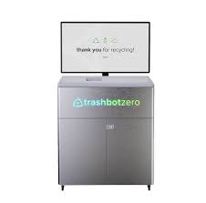

Figure 1: TrashBot. Accessed May 2025.

**Source**: https://cleanrobotics.com/trashbot

**Platform**: Standalone AI-powered smart bin

**Description**: TrashBot automatically sorts waste into recyclables, compostables, and landfill categories at the point of disposal. Using computer vision and machine learning, the system identifies materials in real time and improves accuracy through continuous learning.

**Target Users**: Airports, malls, universities, and high-traffic public areas.

**Relevance**: TrashBot shares core functionality with the proposed system — such as AI-driven classification — but does not incorporate item-specific detection or a reward system for proper recycling behavior.

## 2.3 Bin-e Smart Waste Bin

Another notable smart waste solution is the Bin-e Smart Waste Bin, developed by Bin-e Technologies. As illustrated in Figure 2, Bin-e integrates artificial intelligence, sensors, and IoT connectivity to automate waste classification and compaction. When a user disposes of an item, the bin uses image recognition and weight detection to identify the material type and route it to the appropriate internal compartment. The system also features real-time monitoring, allowing users and administrators to track fill levels and sorting performance via a mobile app or cloud dashboard. Its sleek design and compact form factor make it suitable for office and public environments. However, its reliance on proprietary software and limited customization options can hinder integration into open-source or educational projects.

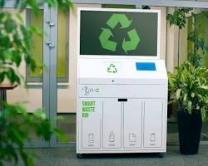

Figure 2: Bin-e smart waste bin in public location. Accessed May 2025.

**Source**: [https://www.bine.world](https://www.bine.world/" \o "https://www.bine.world/)

**Platform**: Indoor smart bin with automatic classification

**Description**: Bin-e uses sensors and AI to recognize, sort, and compress recyclable materials such as plastic, glass, and paper. It offers real-time data reporting and alerts for optimized waste management.

**Target Users**: Offices, educational buildings, medical facilities.

**Relevance**: While Bin-e excels in automation and real-time reporting, it lacks integration with behavior-shaping elements like user feedback or incentive systems, which are central to this project.

## 2.4 Oscar Sort by Intuitive AI

Oscar Sort, developed by Intuitive AI, is an interactive smart bin designed to promote proper waste sorting in office and educational environments. As shown in Figure 3, Oscar combines voice-enabled feedback with computer vision to guide users during disposal. When an item is presented, the system identifies its material type and provides real-time verbal or visual confirmation of correct or incorrect sorting. This user-centric approach emphasizes behavioral change through engagement and education. While Oscar effectively improves recycling compliance, its classification accuracy can be affected by lighting conditions and object orientation, and it does not physically sort waste—relying instead on user cooperation.

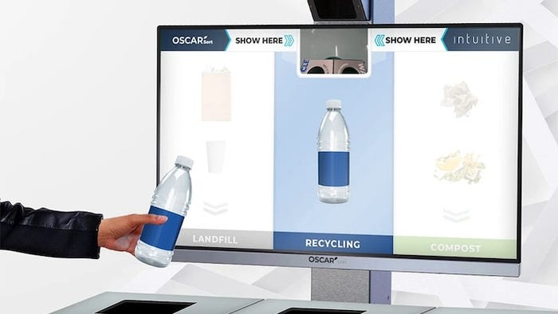

Figure 3: Oscar Sort assistant guiding waste disposal. Accessed May 2025.

**Source**: https://intuitiveai.ca/oscar-sort

**Platform**: AI-powered disposal assistant

**Description**: Oscar Sort scans waste in front of a user and provides real-time instructions on proper disposal via a digital display. It relies on AI object recognition and educates users while preventing incorrect disposal.

**Target Users**: Campuses, corporate sites, retail centers.

**Relevance**: Unlike fully automated systems, Oscar Sort enhances human decision-making rather than replacing it. This contrasts with the proposed system, which automates both classification and sorting but could incorporate similar real-time feedback.

## 2.5 DeepWaste Mobile App

In contrast to hardware-based solutions, the DeepWaste mobile application offers a software-driven approach to waste classification. Illustrated in Figure 4, DeepWaste uses a convolutional neural network (CNN) model to classify waste items from smartphone-captured images. Users simply take a photo of the item, and the app predicts whether it is recyclable, compostable, or landfill-bound, often with educational tips. This low-cost, scalable solution leverages the ubiquity of mobile devices and requires no specialized hardware. However, its effectiveness depends entirely on user initiative and internet connectivity, and it lacks automation or physical sorting capabilities, limiting its impact on consistent behavior change.

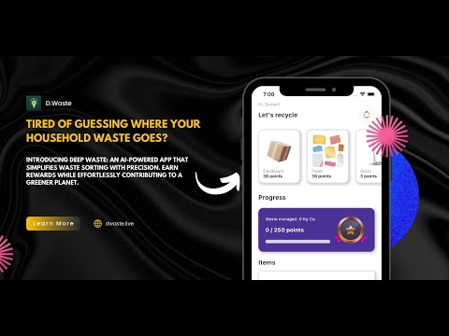

Figure 4: DeepWaste app detecting recyclable packaging. Accessed May 2025.

**Source**: *[https://github.com/sumn2u/deep-waste-app?tab=readme-ov-file](https://github.com/sumn2u/deep-waste-app?tab=readme-ov-file" \o "https://github.com/sumn2u/deep-waste-app?tab=readme-ov-file)*

**Platform**: Mobile application for personal waste classification

**Description**: DeepWaste employs a deep learning model deployed on mobile devices to help users categorize waste into trash, recycling, and compost. Users take a photo, and the app classifies the item with high accuracy.

**Target Users**: Individuals, households, educational users.

**Relevance**: DeepWaste demonstrates lightweight, mobile-compatible AI use — supporting the idea that classification systems can run on lower-power devices, similar to the microcontroller-driven bin in this project.

**2.6 AMP Robotics**

At the industrial scale, AMP Robotics has developed advanced AI-powered robotic systems for large-scale waste processing facilities. As depicted in Figure 5, AMP’s flagship product, the Cortex robot, uses high-speed cameras and machine learning to identify and sort recyclable materials from fast-moving conveyor belts in material recovery facilities (MRFs). With the ability to process thousands of items per hour, the system significantly increases throughput and purity in recycling streams. The technology demonstrates the power of AI in waste management but is designed for centralized infrastructure, making it impractical for decentralized or community-level deployment due to cost and complexity.

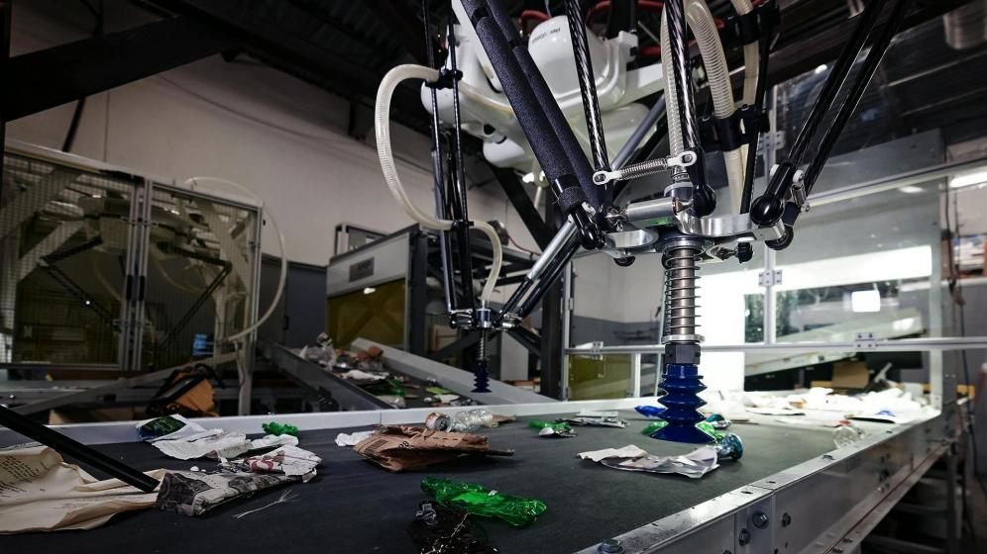

Figure 5: AMP Robotics sorting system in an industrial setting. Accessed May 2025.

**Source**: [https://ampsortation.com](https://ampsortation.com/" \o "https://ampsortation.com/)

**Platform**: AI-powered robotic sorting for industrial recycling plants

**Description**: AMP Robotics builds intelligent recycling robots that use AI to recognize and separate recyclable materials by type, color, shape, and even brand. The systems are deployed in large-scale material recovery facilities (MRFs).

**Target Users**: Municipal waste processors, industrial recyclers.

**Relevance**: While operating at a vastly larger scale, AMP's approach to brand-level recognition and robotic automation mirrors the ambitions of this project — adapted for a compact, affordable unit intended for everyday users.

## 2.7 Conclusion

The reviewed systems demonstrate a growing trend toward integrating AI and automation into waste management, ranging from consumer-facing smart bins like TrashBot and Bin-e to large-scale robotic sorters such as AMP Robotics. While these solutions vary in scale, complexity, and target environment, they collectively emphasize accurate classification, real-time feedback, and operational efficiency. However, many face limitations in cost, accessibility, or reliance on user compliance without sufficient motivation. Notably, most commercial smart bins either require complex multi-compartment hardware or fail to incorporate incentive mechanisms that promote long-term behavioral change. Industrial systems like AMP Robotics achieve high accuracy but are impractical for small-scale or educational settings. Meanwhile, software-only approaches such as DeepWaste improve awareness but lack physical automation.

This analysis highlights a clear opportunity: a system that combines multi-category AI classification with a simplified two-compartment sorting mechanism, making it both intelligent and mechanically feasible for homes, schools, and public spaces. Furthermore, incorporating a reward-based feedback loop—as inspired by interactive systems like Oscar Sort—can enhance user engagement beyond mere automation. The proposed smart bin addresses these insights by prioritizing usability, affordability, and sustainability, bridging the gap between advanced classification and practical, scalable deployment. The lessons drawn from existing work thus directly inform the architecture, functionality, and innovation of the system presented in this project.

# Chapter 3: Research Methodology

## 3.1. Introduction

This chapter outlines the research methodology adopted for the design and implementation of the AI-Driven Smart Bin for waste classification and sorting. It describes the selected development approach, the methods of gathering information, the analysis of current waste disposal practices, and the overall design and engineering strategy of the system.

Given the hardware-software integrated nature of this system—combining embedded electronics, artificial intelligence, and mechanical actuation—this study required both practical experimentation and iterative development. The Agile development methodology was selected to accommodate continuous improvement and modular prototyping.

To guide the design of the system, a custom dataset was created using images of the most frequently discarded waste items in the target deployment environments (e.g., campuses, restaurants, terminals). This was informed by observational research and informal interviews to understand local disposal habits.

This chapter includes the following components:

* Explanation of the chosen system development methodology (Agile)
* Approach to hardware-software co-design
* Information gathering and requirement analysis process
* Basis for selection of tools and technologies
* Initial description of experimental procedures and prototyping

## 3.2. Methodology

### **Phases of Implementation:**

1. **Conception Phase**Defined project scope: Develop a smart bin that uses AI to classify waste items and sorts them accordingly.  
   Early identification of system components and desired functionality.
2. **Setting Up**Defined required hardware (e.g. microcontroller, servo motors, camera module, ultrasonic sensor, coin dispenser, etc.)  
   Identified software tools and frameworks (e.g. YOLOv8 for detection, Python scripts, OpenCV for preprocessing, etc.)  
   Temporary use of an open-source detection dataset for model training; own dataset collection planned to begin shortly
3. **Design**

* High-level architecture was established.
* Modular hardware and software architecture designed.
* Visual representation of system architecture to be included here.

1. **Testability**

* Modules tested independently (e.g. servo motor control, ultrasonic readings).
* Classifier performance will be validated on unseen data from both borrowed and custom datasets.

1. **Implementation**

* Hardware assembly: mounting of camera, motors, and sensors into bin structure.
* Software implementation: real-time image classification and servo control logic.
* Model integration onto microcontroller or connected system (based on final resource evaluation).

1. **Verification**System behavior verification through structured testing scenarios:

* Correct detection and sorting of common recyclable items.
* Accurate detection of full bin state.
* Activation of bin lock and reward dispenser mechanism under correct conditions.

### **System Development Approach**

* Object-Oriented Analysis and Development (OOAD) was adopted for software modules, especially the classification and actuator control subsystems.
* Structured Analysis is applied to physical design and hardware flow (e.g. sensor-triggered actuation).

### **Tools and Technologies**

* Microcontroller: Raspberry Pi (for flexibility and compatibility with vision tasks).
* Software Stack: Python, OpenCV, PyTorch/YOLOv8, Flask (optional for local API), SAM (future for segmentation).
* Hardware Tools: 3D printed components, servo driver modules, power banks, USB camera.

## 3.3 Information Gathering And Analysis

To ensure the AI-Driven Smart Bin meets real-world needs and behaviors, multiple methods were used to gather both technical and user-centered information. These included literature review, field observation, behavioral surveys, and manual waste profiling.

#### **Literature Review and Background Research**

A comprehensive literature review was conducted to study existing smart waste systems, AI-based waste detection models, and environmental behavior trends. This helped identify challenges in public waste disposal, including low participation in recycling programs, contamination in waste streams, and limited adoption of automation in developing regions.

This also informed the feasibility of deploying lightweight object detection models such as YOLOv11 on embedded platforms, and helped refine the mechanical and AI design of the system.

#### **Survey on Local Waste Disposal Behavior**

To understand public behavior and the types of waste most commonly discarded in high-traffic locations (e.g. restaurants, bus stations, campuses), a structured survey was developed. The survey aimed to:

* Identify the most commonly disposed items
* Understand whether people sort their waste before disposal
* Assess public interest in reward-based recycling
* Determine ideal deployment locations for the system

Key survey questions included:

* Frequency of public waste disposal
* Types of waste most frequently thrown away
* Awareness of and participation in waste sorting
* Willingness to interact with smart bins
* Feedback on a reward-based incentive model

Respondents were also asked where they believed smart bins would be most useful. These insights directly guided the selection of classification categories — now focused on:

* Plastic bottles and containers
* Aluminum cans
* Paper and cardboard packaging

These waste types were confirmed to be highly prevalent in common public spaces such as schools, markets, and transportation terminals, unlike glass which was found to be more frequent in private establishments such as bars or restaurants with return policies.

#### **Site Observation and Waste Profiling**

Complementing the survey, informal observations were made in select locations such as a college cafeteria, a small shopping complex, and a bus station. Bins were monitored for volume, frequency of filling, and the types of materials disposed. It was observed that:

* Plastic bottles and food containers were the most frequently discarded
* Aluminum cans, especially from energy drinks and sodas, were common
* Paper waste, such as packaging wraps and receipts, was frequent near food courts and shops

Glass containers, while initially considered, were found to be infrequently discarded in the public areas observed. They are often returned, reused, or rarely sold in non-alcoholic form. This informed the decision to exclude glass from the system’s primary detection categories.

Photographs of disposed items were taken to build a real-world dataset, which is being used to train the object detection model for classification into the three supported waste types.

#### **Requirements Derivation and Stakeholder Needs**

Based on this analysis, a set of user and technical requirements were developed. These were later validated and adjusted during iterative prototyping. Requirements were derived from:

* Environmental concerns (e.g. reducing landfill waste, promoting recycling)
* User needs (e.g. simple and hygienic operation, fast response)
* Technical feasibility (e.g. object detection performance on microcontrollers)
* Feedback from potential users and deployment site managers

These insights informed the final waste categories, reward logic, and mechanical design, and formed the foundation for the Requirements Specification described in the following section.

## 3.4. Requirements Specification

This section outlines the user and system requirements for the Smart Bin. The system is designed to automatically classify and sort three common waste types — plastic, aluminum (metal), and paper — and incentivise responsible recycling behavior through a reward mechanism. The bin must detect when compartments are full and restrict use until emptied, ensuring clean and safe operation in commercial and public environments.

### **3.4.1 User Requirements**

The system must:

* Automatically identify whether a waste item is plastic, metal, or paper.
* Automatically sort each item into the correct compartment without requiring user input.
* Dispense a coin reward (or token) when an item is properly classified and accepted.
* Use lights and/or sound to indicate status (e.g., processing, error, full, idle).
* Lock the input lid and prevent use when any compartment is full to avoid overfilling.
* Be portable and powered by a power bank, not reliant on wall power.
* Classify and respond quickly, with minimal wait time for the user.
* Be safe, with no exposed moving parts, sharp edges, or electric shock risks.

### **3.4.2 System Requirements**

#### **Functional Requirements**

The system must be able to:

* Capture an image of the waste item using a camera module.
* Use an onboard AI object detection model (e.g. YOLO) to classify the item as plastic, paper, or metal.
* Optionally recognize unknown or generic waste items, and reject them.
* Rotate a motorized base/platform to align the correct compartment under the drop mechanism.
* Open a servo-based drop mechanism to release the item into the selected compartment.
* Dispense a coin or token only if the item belongs to a valid class.
* Detect whether a compartment is full using an ultrasonic sensor.
* Automatically lock the bin lid and disable input if the drop area is full.
* Provide feedback to the user using LEDs, screen, or buzzer (e.g., “Please Wait”, “Thank You”, “Bin Full”).
* Log item classifications or decisions for debugging or analytics (optional).

#### **Non-Functional Requirements**

The system should:

* Be cost-effective, built with affordable and widely available components.
* Run on a power bank, consuming low power during idle and active use.
* Complete the classification process in under 2 seconds.
* Complete sorting and reward operations within 5 seconds.
* Be robust and safe for unsupervised public deployment.
* Work in various lighting conditions (e.g., indoor classrooms, covered bus stops).
* Be maintainable, with easily removable compartments for emptying waste.
* Allow future updates to the AI model or software logic if needed.

## 3.5. System Analysis

System analysis is the process of decomposing and understanding the structure, components, and data flow within the proposed smart bin system. It helps refine the system requirements and provides a clear, graphical representation of how components interact. This analysis follows the Structured Analysis and Design (SAD) approach, using diagrams and flowcharts to model system behavior and data interactions.

The system is composed of both hardware and software subsystems that work together to achieve three key objectives:

* Detect and classify incoming waste
* Sort waste into the correct compartment

The following tools and diagrams are used for system analysis:

### **3.5.1 Use Case Diagram**

A use case diagram provides a high-level overview of the functional requirements of a system by illustrating the interactions between external actors and the system’s core functionalities. In the context of the proposed reward-driven smart sorting bin, this diagram captures the primary roles involved—namely, the user (waste disposer) and maintenance staff—and their respective interactions with the Smart Bin System. Figure 6 presents the use case diagram for the system, which outlines how users dispose of waste, receive feedback and rewards, and how maintenance personnel manage the bin’s operation.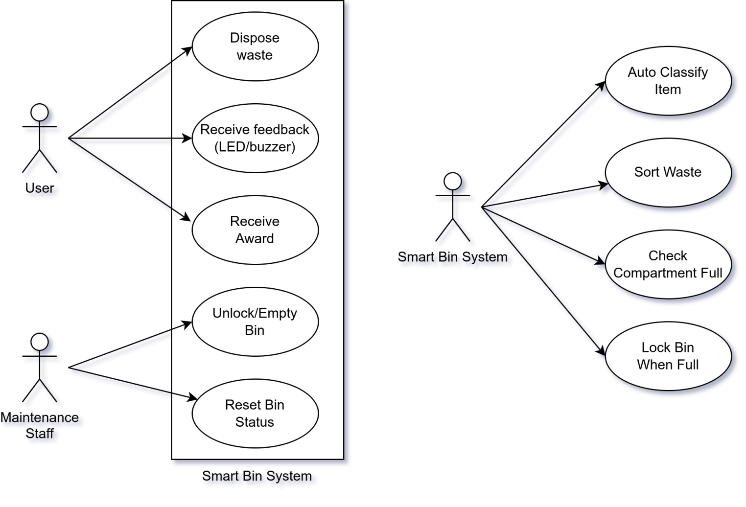

Figure 6: Smart Bin System use case diagram

### **3.5.2 System Flowchart**

This flowchart illustrated in Figure 7 below outlines the overall operation of the smart bin system, from input detection to classification, sorting, and reward dispensing.

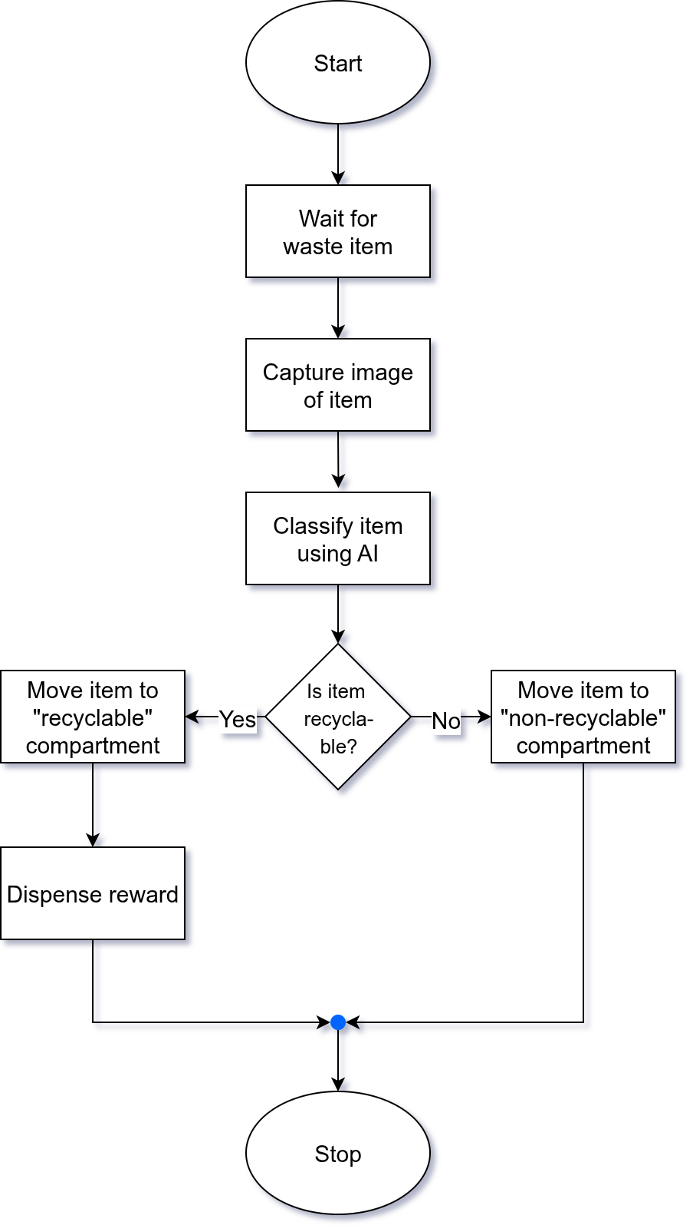

Figure 7: Smart Bin flow chart diagram

### **3.5.3 System Components and Interactions**

The system comprises the following key modules:

* Camera Module – Captures image of the object placed in the bin.
* Microcontroller – Acts as the system’s central control unit, running classification models and actuating motors based on decisions.
* AI Model (YOLOv11) – Classifies the object into one of the supported waste types: plastic, metal, or paper.
* Servo Motors – Control bin locking, platform rotation, and coin dispensing mechanisms.
* Ultrasonic Sensor – Detects whether a compartment is full.
* Power Supply (Power Bank) – Portable power for all components.

The interaction between these modules is managed through firmware that runs on the microcontroller. Logic branches are designed to prevent operation when the bin is full and reward the user only if proper disposal is detected.

## 3.6. Conclusion

This chapter has presented the methodology adopted for the design and implementation of the AI-Driven Smart Bin system. It began by outlining the chosen development approach—Agile methodology—which supports the iterative nature of both hardware prototyping and AI model training. The chapter then detailed the information gathering process, including literature review, site observations, and user surveys, which collectively informed the system's requirements and design decisions.

User and system requirements were carefully specified to guide the integration of mechanical, electronic, and AI components. The system analysis section utilized structured analysis techniques and diagrammatic tools to break down the functional flow of the smart bin, including use case and process interactions.

Together, these activities have laid a solid foundation for the development and implementation phase, ensuring that the smart bin will be both technically feasible and aligned with real-world usage needs

# Chapter 4: System Design

## 4.1. Introduction

This chapter details the design of the Smart Bin: an AI-driven waste sorting system that classifies, sorts, and rewards correct disposal. It covers the system architecture, hardware-software integration, and core modules—including classification, actuation, and incentive mechanisms.

Design decisions were guided by technical feasibility, resource constraints, and real-world usability. For instance, the system focuses on plastic, paper, and metal—identified as most common in public disposal settings through observation and user feedback. On-device inference using a lightweight YOLO model was chosen to balance accuracy, speed, and power efficiency within embedded limitations.

Trade-offs between performance, cost, complexity, and user experience were evaluated through iterative prototyping. The following sections describe the system architecture, module breakdown, interface design, control algorithms, and maintenance considerations. Rationale for key choices is provided, along with reflections on challenges faced. Survey results will later inform final refinements to the design and deployment strategy.

## 4.2. System Analysis

The Smart Bin addresses the inefficiency of traditional waste bins, which often result in contaminated streams and low recycling rates. The core challenge is the lack of accessible, automated systems that sort waste accurately and encourage proper disposal behavior.

Based on requirements from literature, observation, and surveys, the system must:

* Classify waste (plastic, metal, paper) in real time.
* Automatically sort items into designated compartments.
* Detect full bins and prevent overfilling.
* Provide feedback via LED/buzzer.
* Dispense rewards to incentivize users.
* Operate autonomously on portable power in public spaces.

Key constraints include low latency, high classification accuracy, safety, and durability. Future-proofing features such as usage logging, wireless monitoring, and over-the-air model updates are also considered.

This analysis defines what the system must achieve; the subsequent design details how these goals are realized technically.

## 4.3. Context Model

The context model illustrated in Figure 8 defines the boundaries between the Smart Bin system and its external environment. It identifies all the external entities that interact with the system and the nature of data or control flows exchanged with them.

At the center of the model is the Smart Bin System, which is influenced by multiple external entities. These include the User, who disposes of waste and receives feedback or rewards; the Maintenance Staff, who empties compartments and resets the bin; the Power Source, which provides energy for all operations; and the physical environment, particularly lighting conditions that may affect the performance of the vision system. Additionally, survey participants and datasets form part of the contextual environment during development and training of the AI model.

These interactions are visually represented in the system’s context diagram, which forms the basis for identifying system boundaries, responsibilities, and external interfaces during design.

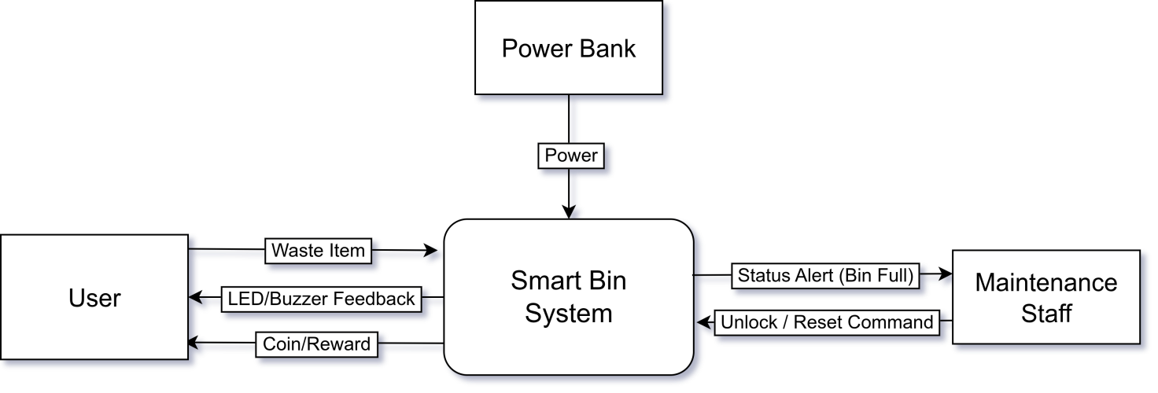

Figure 8: Smart Bin context diagram

## 4.4. Design Methods

### 4.4.1. Architectural Design

The architectural design of the Smart Bin System outlines the high-level structure of both the hardware and software subsystems, and how they interact to meet the functional and non-functional requirements. The architecture is designed for modularity, allowing each component to handle a specific responsibility within the overall system workflow.

#### Hardware Architecture

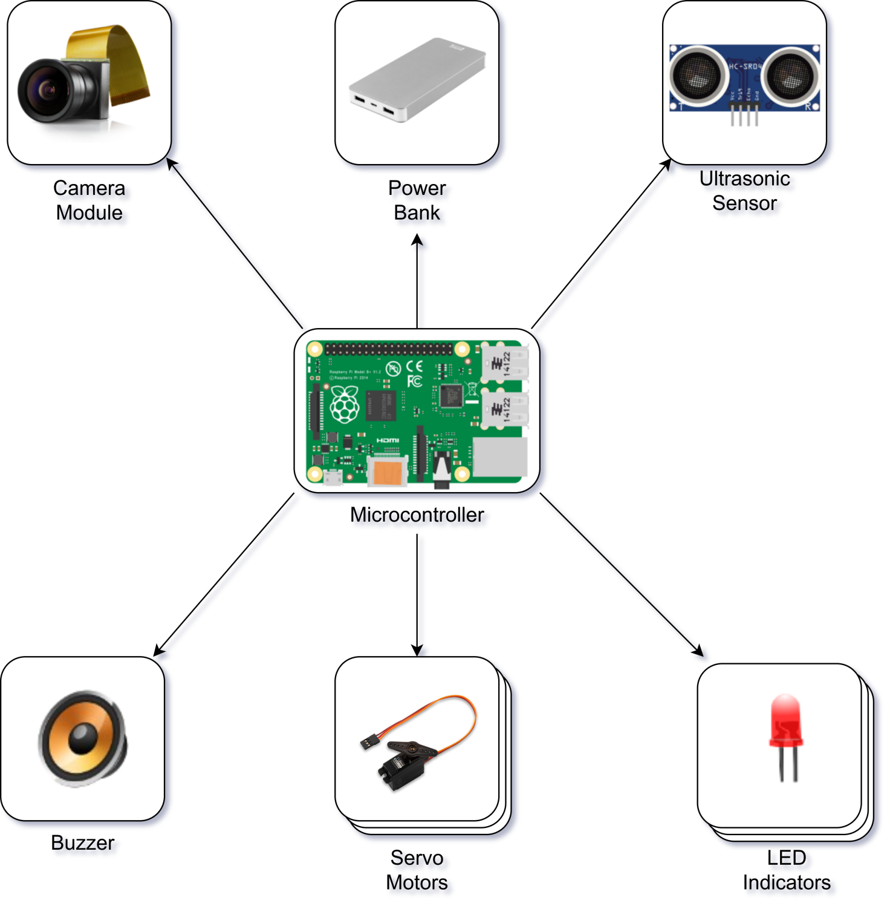

Figure 9: Smart Bin Architectural Design Diagram

* Power Bank: Portable power source to supply to all hardware components
* Microcontroller: Core processing unit for input/output control and integration logic
* Camera Module: Captures images of incoming waste for classification
* Servo Motor 1: Rotates platform to align the correct compartment beneath the drop point
* Servo Motor 2: Controls the lid opening/closing and drop release mechanism
* Servo Motor 3: Activates coin dispenser for reward when recyclable material is detected
* LED Indicator: Provides visual feedback (e.g., bin full, item accepted, error state)
* Speaker/Buzzer: Emits sound for alerts (e.g., successful drop, bin full, invalid item)

#### Software Architecture

The software component is structured into modules:

* Image Capture Module – interfaces with the camera to obtain images
* AI Classification Module – runs a YOLO-based model to classify the object into plastic, paper, or metal
* Control Logic Module – interprets classification results and manages mechanical operations (rotation, dropping, locking)
* Feedback Module – activates LEDs and buzzer signals
* Fullness Monitoring Module – reads from the ultrasonic sensor and determines whether to lock input
* Reward Module – controls coin dispensing logic

This modular architecture ensures clear separation of concerns and supports future scalability, such as adding data logging, wireless connectivity, or remote monitoring features.

#### System Integration

The microcontroller acts as the central processing and coordination unit, interfacing with sensors and actuators in real time. The entire system operates offline and autonomously, powered by a portable power source. The architecture has been designed to meet requirements for speed, accuracy, portability, and safety in public environments.

### 4.4.2. Detailed Design

The detailed design phase breaks down the Smart Bin System into individual functional modules and describes the behavior, logic, and interfaces of each module. The system follows a modular approach to ensure separation of concerns, ease of testing, and scalability. Each module is responsible for a specific function within the waste classification, sorting, and reward workflow. The design methodology used is Structured Analysis and Design (SAD), and system logic is further expressed through a Data Flow Diagram and pseudocode.

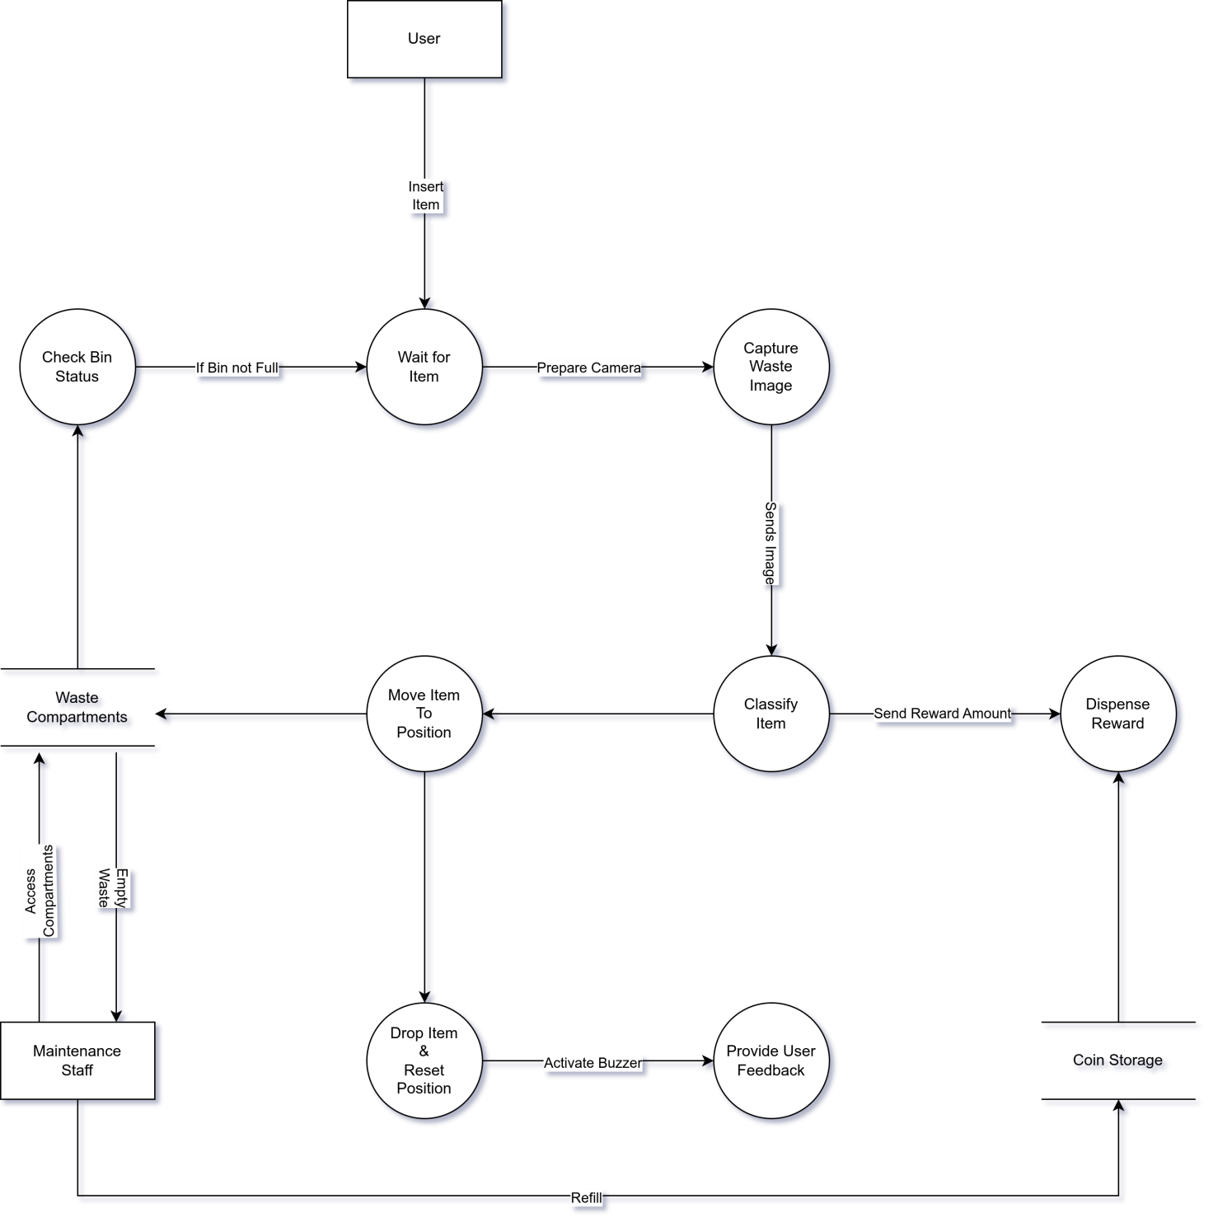

Figure 10: Smart Bin Data Flow Diagram

* **1. Image Capture Module**

Purpose: This module captures an image of the waste item once inserted by the user.

* Input: Trigger signal when bin lid is closed
* Output: Still image (frame) sent to classification module
* Interface: Camera module (e.g., ESP32-CAM or USB camera)
* Process:
* Wait for lid to close
* Capture high-resolution image
* Send image to AI classification module
* **2. AI Classification Module**

Purpose: Performs object detection using a lightweight YOLOv5 model to identify the material type.

* Input: Image from camera
* Output: Waste class label (plastic, paper, metal) or unknown
* Process:
  + Preprocess the input image
  + Run inference using pre-trained YOLO model
  + Return the class with highest confidence
* Design Choice: YOLO was chosen for its speed, accuracy, and ability to run on low-resource devices with quantized weights.

Pseudocode (simplified):

|  |
| --- |
| def classify(image):  result = yolo\_model.predict(image)  if result.label in [“plastic”, “metal”]:  return “recyclable”  return "non-recyclable" |

* **3. Rotational Motion Control Module**

Purpose: Moves the waste container horizontally (along a track or guide rail) to position it above the correct waste compartment (plastic, paper, or metal).

Input: Waste class label from AI module

Output: Positioning signal to a linear actuator or belt-driven motor

Interface: Stepper motor or DC motor with position feedback (e.g., via limit switches or encoders)

Process:

* Map each class label to a fixed horizontal position:  
  Recyclable→ position A  
  Non-recyclable→ position B
* Activate the motor to translate the container horizontally until the correct position is reached
* Optionally, use limit switches or sensor feedback to detect arrival at each position
* Signal the dropping mechanism module to proceed with releasing the item
* **4. Reward Module**

Purpose: Dispenses a coin/token if the item is correctly classified and dropped.

Condition: Only dispense reward for classified recyclable items (plastic, metal, or paper).

If the classification result is anything else, no reward is dispensed.

Input: Classification result - recyclable

Output: Servo actuation to release a coin

Interface: Servo motor on coin dispenser

Process:

* Trigger servo for brief release motion
* Wait fixed duration
* Reset dispenser

### 4.4.3. Physical Design

The physical design of the Smart Bin system outlines how users interact with the device, how internal components are arranged, and how data and items move throughout the system. It focuses on input and output design, mechanical layout, and real-world usability in public or commercial settings.

#### **a) User Interaction**

Users interact with the system by placing a waste item into the input container located at the top of the bin. Once the item is inserted and the lid is closed, the bin temporarily locks to prevent interference during processing. After classification and sorting are complete, the bin automatically reopens, and — if applicable — dispenses a coin as a reward for proper disposal. The system uses LED indicators and/or a buzzer to inform the user of current status (e.g., idle, processing, full).

#### **b) Mechanical Layout**

The bin is divided into two compartments: recyclable and non-recyclable. The top container holding the waste item is mounted on a linearly translating platform (e.g., a belt or guide rail) controlled by a motor. After classification, the platform slides horizontally to align the container with the correct compartment. A servo-driven trapdoor beneath the container then opens, allowing the item to drop.

The compartments may each have a dedicated ultrasonic sensor to detect fullness. When a compartment is full, the system prevents further drops into that section and alerts maintenance staff.

#### **c) Data and Control Flow**

The camera module captures the image, which is classified by an onboard AI model. The result determines which compartment to move to. After verifying that the target compartment is not full, the bin executes the drop and optionally dispenses a coin. If the item is unrecognized, it is directed to the miscellaneous compartment and no reward is given.

#### **d) Output and Feedback**

Visual and auditory feedback is provided to users at each stage of the interaction:

* Green LED: Idle/Ready
* Yellow LED: Processing
* Red LED or buzzer: Full bin / error
* Coin slot and dispenser: Rewards for valid items

The design prioritizes portability, mechanical stability, and public safety, with all moving parts enclosed and accessible only for maintenance.

## 4.5. Conclusion

This chapter has detailed the overall design and architectural framework of the AI-Driven Smart Bin system. It began with the selection of a modular, structured approach for both hardware and software design, guided by the Structured Analysis and Design (SAD) methodology.

The design was broken down into architectural, detailed, and physical layers. At the architectural level, the high-level structure and hardware-software interaction were defined. The detailed design outlined the internal modules — such as image capture, classification, sorting logic, reward dispensing, and user feedback — while the physical design emphasized real-world interaction, internal layout, and 3D structural representation.

Furthermore, a comprehensive Data Flow Diagram (DFD) was developed to visually communicate the movement of data throughout the system, highlighting the interactions between the user, maintenance staff, control logic, and data stores. This structured breakdown provides a foundation for the implementation phase, ensuring all critical functions are addressed and logically connected.

The design also reflects the project's scalability, safety, and sustainability goals — providing a blueprint not only for prototyping but also for future iterations or enhancements.

# Chapter 5: Implementation

## 5.1 Introduction

Implementation refers to the practical realization of the Smart Bin system, transitioning the design specifications into a working prototype. This chapter outlines the hardware and software integration, explains how the ESP32-CAM, multiplexer, motors, and sensors are orchestrated to deliver functionality, and details the algorithms used for object classification and control. It also includes aspects of project management such as risk mitigation, configuration management, and system cutover considerations. The aim is to demonstrate how the theoretical design has been transformed into a functional, deployable solution.

## 5.2 System Implementation

### 5.2.1 Hardware Implementation

The system is built around the ESP32-CAM microcontroller, chosen for its low cost, integrated Wi-Fi capabilities, and onboard camera support. To manage the multiple motors and peripherals despite limited GPIO pins, a multiplexer is used, enabling sequential control of the devices.

The major hardware components include:

* ESP32-CAM: Central controller handling image acquisition, classification, and peripheral control.
* Motors (2 total):
* Sliding motor – moves the temporary box horizontally to align with the correct storage bin.
* Coin dispenser motor – provides incentives to users after correct disposal.
* Ultrasonic sensor: Detects the presence of a trash item inside the temporary holding box.
* Camera module (integrated with ESP32-CAM): Captures an image of the trash item for classification.

### 5.2.2 Software Implementation

This screenshot in Figure 11 below displays the graphical user interface of the smart bin system, which runs on a connected laptop. The application establishes communication with the ESP32 microcontroller via Bluetooth. Upon powering on, the ESP32 waits for a connection; clicking "Connect" in the UI initiates the handshake and enables full system functionality. During operation, images captured by the bin’s camera are transmitted to the computer for real-time preview and AI classification. The results are then sent back to the ESP32 to trigger feedback (e.g., LED indicators) and actuation (e.g., sorting mechanism). This seamless bidirectional communication ensures accurate waste classification and responsive user interaction.

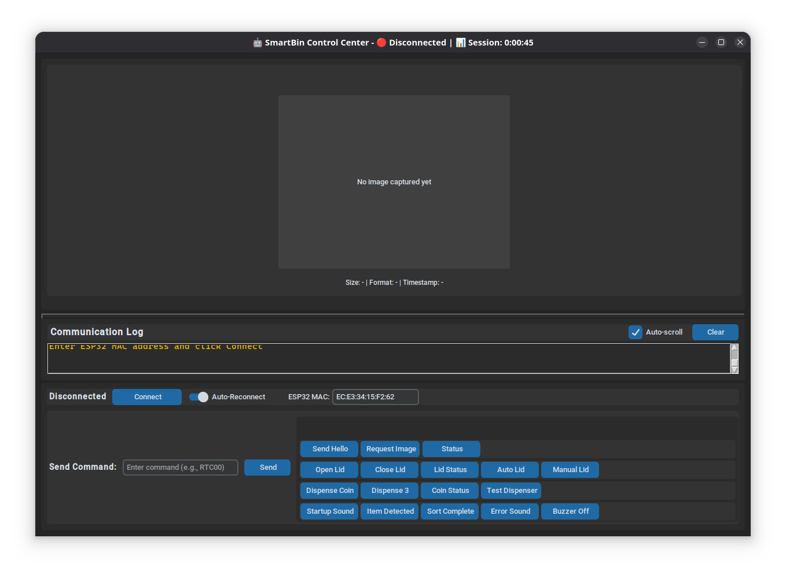

Figure 11: System user interface used for monitoring and controlling the smart bin.

## 5.3 Coding

The implementation relies on modular Arduino C++ code, divided into separate modules for:

* Motor control
* Ultrasonic sensor measurement
* Camera capture and classification

## 5.4 Results

The implementation produced a functional prototype capable of autonomously detecting, classifying, and sorting waste items. The system successfully demonstrated the integration of sensors, motors, and machine learning classification on constrained hardware.

Observed system behaviors include:

* The ultrasonic sensor reliably detects the presence of an item in the temporary holding box.
* The ESP32-CAM captures images and runs the TensorFlow Lite Micro model, producing a classification among four categories: paper, metal, glass, miscellaneous.
* The sliding motor moves the holding box horizontally to the correct bin location.
* The dropper motor releases the item accurately into the designated bin.
* The lid motor operates automatically to allow items to be placed and then closes the bin.
* The coin dispenser motor activates correctly after successful disposal, providing a reward mechanism.
* LED indicators show the system state: ready, processing, or error.

The results confirm that the Smart Bin meets its functional requirements, although optimization of classification accuracy depends on dataset quality and lighting conditions.

## 5.5 Conclusion

The implementation phase has transformed the Smart Bin from a conceptual design into a working prototype. By combining computer vision, embedded machine learning, and electromechanical actuation, the system demonstrates how waste sorting can be automated efficiently using affordable components.

Key achievements include:

* Integration of four motors and peripheral devices via a multiplexer, overcoming GPIO limitations.
* Reliable detection and sorting of items through a well-structured control algorithm.
* Inclusion of a coin dispenser incentive mechanism, enhancing system usability.

This chapter validates that the Smart Bin’s design is practical, cost-effective, and implementable within real-world scenarios such as public spaces and campuses.

# Chapter 6: Testing and Results

## 6.1 Introduction

Testing is a critical stage of system development, intended to verify that the Smart Bin prototype functions according to specifications. The purpose of testing is to identify and correct faults, ensure that both hardware and software modules perform reliably, and evaluate whether the integrated system meets user expectations. This chapter describes the testing strategies used, presents the results obtained, and provides analysis of the system’s performance.

## 6.2 Test Plan

The testing was divided into several stages to ensure comprehensive validation:

1. Unit Testing – focused on individual hardware and software components, including motors, ultrasonic sensor, LEDs, ESP32-CAM, and classification code.
2. Integration Testing – verified interaction between subsystems such as sensor detection with camera capture, or classification with motor actuation.
3. System Testing – evaluated the Smart Bin as a whole, running the full sequence from trash detection to disposal and reward dispensing.
4. User Testing – although limited, a conceptual evaluation was conducted by simulating real-world use cases to assess usability.

## 6.3 Test Environment

Testing was performed indoors in laboratory conditions under varying lighting levels. Since lighting directly influences image quality and therefore classification accuracy, results were observed under both bright and dim environments. A Bluetooth connection to a laptop was used to run the classification model externally and send results back to the ESP32-CAM. This workaround improved performance speed during testing.

## 6.4 Test Cases and Results

### 6.4.1 Unit Testing

* Motors: Each of the four motors was tested individually to verify motion and direction. Results showed consistent operation with negligible lag.
* Ultrasonic Sensor: Successfully detected items placed in the temporary holding box within a range of 2–15 cm. Accuracy decreased for smaller or irregularly shaped items.
* Camera Module: Captured clear colorimages in bright light; noise increased under dim light.

Result: All unit tests passed, although environmental factors affected sensor and camera performance.

### 6.4.2 Integration Testing

* Ultrasonic + Camera: Item detection reliably triggered image capture.
* Camera + Classification: Images captured were successfully transmitted via Bluetooth to a laptop for model inference, then results returned to the ESP32-CAM.
* Classification + Motor Control: Motor actuation responded correctly to classification outputs, moving the temporary holding box to the assigned bin.

Result: Integration tests passed, but reliance on Bluetooth increased complexity.

### 6.4.3 System Testing

A complete cycle was tested:

1. Item detected by ultrasonic sensor.
2. Camera captured image and transmitted to laptop.
3. Model classified item (paper, metal, glass, misc).
4. Sliding motor pushed item to correct bin.
5. Coin dispenser activated where applicable.
6. System reset.

Result:

* Success rate of end-to-end cycle: over 75%.
* Failures occurred due to misclassification (approx. 25% error rate), occasional delays in Bluetooth communication, and difficulty in detection of irregular objects.

### 6.4.4 User Testing

Although not formally conducted, simulated user trials were carried out. When operated as intended, the system was intuitive, with LEDs providing useful feedback. Users were expected to place items individually, as multiple simultaneous items confused the detection and classification process.

Result: Indicated general usability but highlighted the need for more robust instructions for end users.

## 6.5 Analysis

Testing confirmed that the Smart Bin prototype is functional and demonstrates the feasibility of automated waste classification. However, several challenges were observed:

* Classification Accuracy: At approximately 70%, the model requires improvement through larger datasets and optimized training.
* Environmental Sensitivity: Lighting conditions affected both image clarity and classification accuracy.
* Hardware Limitations: The ESP32-CAM alone was insufficient for real-time classification; external offloading via Bluetooth improved speed but reduced self-containment.
* System Robustness: Motors and sensors were reliable, though occasional misalignment of the sliding box occurred due to mechanical tolerances.

Despite these issues, the system consistently demonstrated the core process of detection, classification, and disposal.

## 6.6 Conclusion

The testing phase validated that the Smart Bin meets its basic requirements. It successfully integrates hardware and software to detect waste items, classify them, and perform automated disposal with incentive dispensing. The system’s main limitation lies in classification accuracy and reliance on external processing, but the prototype establishes a strong foundation for future optimization.

# CHAPTER 7: DISCUSSION, CONCLUSION AND RECOMMENDATIONS

## 7.1 Discussion

The Smart Bin prototype demonstrates the feasibility of using embedded systems and lightweight machine learning for automated waste sorting. The ESP32-CAM provided a cost-effective, compact solution integrating camera and microcontroller functions. A multiplexer resolved GPIO limitations, enabling control of multiple servos and LEDs.

However, several challenges were identified:

* Accuracy Concerns: Classification accuracy (~70%) was affected by lighting, background clutter, and object orientation.
* System Sensitivity: The ultrasonic sensor occasionally failed to detect irregularly shaped items, leading to false or missed triggers.

Despite these issues, the system successfully demonstrated end-to-end functionality—from detection to sorting and feedback.

## 7.2 Conclusion

This project designed and implemented a smart bin capable of detecting, classifying, and sorting waste using embedded AI. Key outcomes include:

* The ESP32-CAM is suitable for low-cost vision tasks but requires optimization for real-time inference.
* System testing achieved a 75% success rate in complete operation cycles.
* While functional, the classification model needs refinement for higher accuracy and environmental robustness.

The prototype confirms that intelligent waste management can be realized with affordable, accessible technology—offering both educational value and potential for scalable deployment.

## 7.3 Recommendations

To enhance performance and scalability:

* Model Optimization: Train on a larger, diverse dataset; explore grayscale input and quantized models (e.g., MobileNet, Edge Impulse) for edge deployment.
* Hardware Upgrades: Replace SG90 servos with steppers or continuous rotation motors; add limit switches for precise positioning; improve structural rigidity.
* Power Management: Use a regulated 5V supply with polarity protection; optimize motor usage to reduce heat and power draw.
* User Interaction: Add an OLED display or audio feedback for richer user guidance.
* Future Work: Conduct field tests in schools or public areas; scale into networked bins; integrate mobile apps for reward tracking and remote monitoring.

# REFERENCES

BasicAI. (n.d.). *Smart waste classification: A step towards a sustainable future*. [https://www.basic.ai/blog-post/smart-waste-classification](https://www.basic.ai/blog-post/smart-waste-classification" \t "/home/bulaya/Documents\\x/_blank)

CleanRobotics. (2023). *TrashBot: Redefining waste sorting with AI-powered automation*. [https://www.cleanrobotics.com/trashbot](https://www.cleanrobotics.com/trashbot" \t "/home/bulaya/Documents\\x/_blank)

Everwave. (2025, January 13). *Artificial intelligence in waste detection*: Opportunities and challenges for a sustainable future. [https://everwave.de/en/2025/01/13/artificial-intelligence-in-waste-detection-opportunities-and-challenges-for-a-sustainable-future/](https://everwave.de/en/2025/01/13/artificial-intelligence-in-waste-detection-opportunities-and-challenges-for-a-sustainable-future/" \t "/home/bulaya/Documents\\x/_blank)

Li, Y., Yang, D., Sun, Y., & Wang, Y. (2021). Motivating recycling behavior—Which incentives work, and why? *Psychology & Marketing*, 38(9), 1525–1537. [https://doi.org/10.1002/mar.21496](https://doi.org/10.1002/mar.21496" \t "/home/bulaya/Documents\\x/_blank)

Lin, C.-Y., & Chen, S.-C. (2022). Gamification and incentive design in urban recycling programs: Evidence from Taiwan’s “Green Points” system. *Resources, Conservation & Recycling, 176*, 105942. [https://doi.org/10.1016/j.resconrec.2021.105942](https://doi.org/10.1016/j.resconrec.2021.105942" \t "/home/bulaya/Documents\\x/_blank)

MDPI. (2022). The impact of reward–penalty policy on different recycling modes of recyclable resources in residential waste. *Sustainability, 13*(14), 7883. [https://doi.org/10.3390/su13147883](https://doi.org/10.3390/su13147883" \t "/home/bulaya/Documents\\x/_blank)

MDPI. (2023a). The social dimensions of an incentive-based urban recycling program: A case-study from Istanbul, Turkey. *Sustainability, 15*(22), 15775. [https://doi.org/10.3390/su152215775](https://doi.org/10.3390/su152215775" \t "/home/bulaya/Documents\\x/_blank)

Nasir, I., & Aziz Al-Talib, G. A. (2023). Waste classification using artificial intelligence techniques: Literature review. *Technium: Romanian Journal of Applied Sciences and Technology, 5*(1), 49–59. [https://techniumscience.com/index.php/technium/article/view/8345](https://techniumscience.com/index.php/technium/article/view/8345" \t "/home/bulaya/Documents\\x/_blank)

PMC (PubMed Central). (2020). Domestic waste recycling, collective action and economic incentive: The case in Hong Kong. *International Journal of Environmental Research and Public Health, 17*(7), 2478. [https://doi.org/10.3390/ijerph17072478](https://doi.org/10.3390/ijerph17072478" \t "/home/bulaya/Documents\\x/_blank)

Papers With Code. (n.d.). *Garbage classification dataset*. [https://paperswithcode.com/dataset/garbage-classification-dataset](https://paperswithcode.com/dataset/garbage-classification-dataset" \t "/home/bulaya/Documents\\x/_blank)

ResearchGate. (2023). *Literature mapping of waste sorting and recycling behavior research: A visual analysis using CiteSpace*. Environmental Science and Pollution Research. [https://doi.org/10.1007/s11356-023-27295-5](https://doi.org/10.1007/s11356-023-27295-5" \t "/home/bulaya/Documents\\x/_blank)  
(Original work by Zhao, Y., & Zhang, J., 2023)

ResearchGate. (2025). *Determinants of household-level solid waste sorting practice: The case of Bure town, North-western Ethiopia*. Cogent Social Sciences. [https://doi.org/10.1080/23311886.2025.2483388](https://doi.org/10.1080/23311886.2025.2483388" \t "/home/bulaya/Documents\\x/_blank)  
(Original work by Melese, M., Assefa, Y., & Meselu, Y., 2025)

ResearchGate. (n.d.). *Waste management using machine learning and deep learning algorithms*. [https://www.researchgate.net/publication/347862723\_Waste\_Management\_Using\_Machine\_Learning\_and\_Deep\_Learning\_Algorithms](https://www.researchgate.net/publication/347862723_Waste_Management_Using_Machine_Learning_and_Deep_Learning_Algorithms" \t "/home/bulaya/Documents\\x/_blank)

SDGs UN. (2023, May). *AI application for solid waste sorting in Global South* [Policy brief]. United Nations Department of Economic and Social Affairs. [https://sdgs.un.org/sites/default/files/2023-05/A41%20-%20Thien-An%20Tran%20Luu%20-%20AI%20Application%20for%20Solid%20Waste%20in%20the%20global%20south.pdf](https://sdgs.un.org/sites/default/files/2023-05/A41 - Thien-An Tran Luu - AI Application for Solid Waste in the global south.pdf" \t "/home/bulaya/Documents\\x/_blank)

SBN (Simple But Needed). (2024). *What are the challenges faced in waste management for small businesses*? [https://sbnsoftware.com/blog/what-are-the-challenges-faced-in-waste-management-for-small-businesses/](https://sbnsoftware.com/blog/what-are-the-challenges-faced-in-waste-management-for-small-businesses/" \t "/home/bulaya/Documents\\x/_blank)

SBN (Simple But Needed). (2025). *What are the emerging trends in waste management practices*? [https://sbnsoftware.com/blog/what-are-the-emerging-trends-in-waste-management-practices/](https://sbnsoftware.com/blog/what-are-the-emerging-trends-in-waste-management-practices/" \t "/home/bulaya/Documents\\x/_blank)

Sorted Technologies. (2025, March 25). *Key benefits of computer vision for waste sorting*. [https://sorted.tech/blog/key-benefits-of-computer-vision-for-waste-sorting](https://sorted.tech/blog/key-benefits-of-computer-vision-for-waste-sorting" \t "/home/bulaya/Documents\\x/_blank)

UNEP. (2024). *Global waste management outlook 2024*. United Nations Environment Programme. [https://www.unep.org/resources/report/global-waste-management-outlook-2024](https://www.unep.org/resources/report/global-waste-management-outlook-2024" \t "/home/bulaya/Documents\\x/_blank)

Waste Technology. (n.d.). *5 top household municipal solid waste sorting equipment technologies*. [https://waste-technology.co.uk/5-top-household-municipal-solid-waste-sorting-equipment-technologies.html](https://waste-technology.co.uk/5-top-household-municipal-solid-waste-sorting-equipment-technologies.html" \t "/home/bulaya/Documents\\x/_blank)

Zhang, J., Zhao, Y., & Liu, X. (2021). DeepWaste: A mobile application for real-time waste classification using deep learning. *IEEE Access, 9*, 87654–87663. [https://doi.org/10.1109/ACCESS.2021.3087654](https://doi.org/10.1109/ACCESS.2021.3087654" \t "/home/bulaya/Documents\\x/_blank)

# APPENDICES

## APPENDIX I: PROJECT PROPOSAL

### 1. Background Information

Waste management is one of the most pressing environmental challenges of the modern era. As global populations grow and urbanization accelerates, the volume of waste generated continues to increase at an alarming rate. Traditional waste disposal methods, such as landfilling and incineration, contribute significantly to environmental degradation, including soil contamination, air pollution, and greenhouse gas emissions.

Recycling is a widely recognized solution to mitigate these impacts, yet its effectiveness is often hindered by improper waste segregation at the source. Many people dispose of waste incorrectly due to a lack of awareness, leading to recyclable materials ending up in landfills. Manual waste sorting is labor-intensive, inefficient, and often hazardous, exposing workers to health risks.

The advent of **artificial intelligence (AI), computer vision, and Internet of Things (IoT) technologies** presents an opportunity to revolutionize waste management. Smart waste sorting systems powered by AI can significantly enhance the efficiency and accuracy of waste classification, ensuring that recyclable materials are properly identified and redirected to the appropriate recycling channels. This project proposes the development of an **AI-driven smart bin** capable of automatically sorting waste based on material type, thus promoting sustainable waste management practices and reducing landfill waste.

### 2. Introduction

In recent years, waste generation has increased due to rapid industrialization, urbanization, and changes in consumer behavior. The improper disposal of waste has led to severe environmental problems, including pollution, depletion of natural resources, and increased carbon emissions. While many countries have implemented recycling programs, these efforts are often undermined by **inefficient sorting** at the disposal stage. The reliance on **human labor** for waste segregation is not only costly and inefficient but also poses health risks to workers handling hazardous materials.

With advancements in **machine learning, image recognition, and IoT-based automation**, AI-driven solutions can address these challenges by introducing **smart waste sorting systems**. These systems leverage **computer vision and AI models** to identify and classify waste into categories such as plastics, metals, paper, and organic waste. By automating waste sorting, this project aims to reduce human effort, improve recycling rates, and contribute to a more sustainable future.

The **Smart Bin: AI-Driven Waste Sorting** project proposes the development of an intelligent waste management system that uses **computer vision and sensor-based detection** to automatically classify and sort waste into designated compartments. The system will be designed to be user-friendly, cost-effective, and adaptable for both household and industrial use.

This document is structured as follows:

* Background Information: Discusses the importance of waste management and the need for automation in sorting.
* Problem Statement: Identifies key challenges in current waste sorting methods and the motivation behind this project.
* Objectives: Outlines the primary and specific objectives of the project.
* Scope of Study: Defines the limitations and coverage of the research.
* Literature Review: Examines existing solutions and research related to smart waste management.
* Research Methodology: Describes the techniques, tools, and approaches used in developing and testing the system.
* Significance of the Study: Explores the potential impact of this project on environmental sustainability and waste management efficiency.
* Expected Contribution and Implications: Discusses how this project can contribute to technological and social advancements.
* Ethical Considerations: Reviews the ethical concerns surrounding AI-based waste sorting.
* Project Timeline and Budget: Provides a breakdown of the project phases and expected financial costs.

### 3. Problem Statement

Waste mismanagement remains a **global environmental and economic issue**, contributing to excessive landfill waste and pollution. A key challenge in recycling is the **incorrect sorting of materials**, which contaminates recyclables and reduces their efficiency. Current waste management solutions **lack automation and rely on human intervention**, making them prone to errors and inefficiencies.

To address this issue, a **Smart Bin with AI-driven waste classification** will be developed to **automatically identify and separate waste materials**. This will **improve recycling efficiency, reduce human sorting efforts, and encourage proper waste disposal behaviors**.

### 4. Objective

To design and develop a **Smart Bin that automatically identifies, classifies, and sorts waste** using **computer vision and IoT technology**, enhancing **waste recycling efficiency and reducing landfill waste**.

#### Specific Objectives

1. **Develop an AI-based waste classification system** capable of identifying **plastic, metal, and organic waste**.
2. **Implement a motorized sorting mechanism** that directs waste into the appropriate compartment.
3. **Develop an IoT-based system** for real-time monitoring of waste levels and collection schedules.
4. **Test and evaluate** the system’s sorting accuracy, efficiency, and effectiveness in a real-world setting.

### 5. Hypothesis and Assumptions

* The **AI model** can reliably classify and sort waste materials with **high accuracy**.
* Users will **comply with using the system correctly**, reducing contamination in recyclable materials.
* The **automated sorting mechanism** will be **efficient and reliable**, reducing manual intervention in waste management.
* The system’s **IoT functionality** will improve waste collection efficiency and **minimize overflow issues**.

### 6. Scope of Study

This study focuses on the **design, development, and evaluation** of an **AI-driven smart bin** capable of automatically sorting waste into different categories based on material composition. The system will utilize **computer vision, machine learning, and sensor-based detection** to classify and separate waste into recyclable and non-recyclable compartments. The primary goal is to enhance waste management efficiency, promote recycling, and reduce human intervention in waste sorting.

The scope of the study includes the following key areas:

1. **Technical Feasibility** – Developing and testing a prototype smart bin equipped with AI-powered waste classification, image recognition, and automated sorting mechanisms.
2. **User Adoption & Behavior Analysis** – Investigating how users interact with the smart bin and identifying factors influencing their willingness to use AI-driven waste sorting solutions.
3. **System Integration & Scalability** – Exploring how the smart bin could be integrated into **municipal waste management systems, recycling plants, and commercial facilities** to enhance large-scale waste sorting.
4. **Material Recognition Limitations** – Identifying potential challenges in waste identification, such as **mixed-material waste, contaminated recyclables, and AI misclassification**, and evaluating strategies to improve sorting accuracy.
5. **Power Consumption & Sustainability** – Assessing the energy requirements of the system and exploring sustainable power sources such as **solar panels or low-energy microcontrollers**.
6. **Data Privacy & Ethical Considerations** – Evaluating the ethical implications of using AI in waste management, including **data privacy concerns** if the system collects and processes user-related waste data.
7. **Economic Feasibility** – Analyzing the cost-effectiveness of the smart bin prototype and its potential for large-scale production, including **manufacturing costs, maintenance, and long-term benefits**.

The study will primarily focus on **small-scale and controlled environments**, such as **universities, offices, or residential communities**, to test the effectiveness of the prototype. However, the findings will also explore its applicability in **industrial and municipal waste management**.

### 7. Literature Review

#### Waste Management Challenges in Zambia

Zambia like many developing countries has not been spared from a number of environmental challenges one of which is, inappropriate management of waste. It is estimated that only about 7 percent of urban and rural populations have access to refuse collection and the most common method of disposal is pitting and uncontrolled dumping.  Illegal open air burning of waste is one of the most common practices for reducing waste volume. Waste is generally not segregated according to waste streams, but disposed of together through a combination of informal, public and private channels. The management of solid waste has over the years been a challenging issue in Zambia and is potentially contributing to public health and environmental implications. According to the Living Conditions Monitoring Survey of 2013/14, only 7% of households (15% urban and 2% rural) had their waste collected. (Nkwazi Magazine, 2019).

#### Importance of Sorting Waste

By separating different materials, most of them can also be recycled into new products. We save energy and natural resources by using materials multiple times. Waste sorting is part of the EU’s plan to manage our waste so that the environment and people are not harmed. Sorting our waste also reduces the amount of waste at risk of going to landfill. (“*Facts about waste management*”, 2023)

#### Existing Waste Sorting Methods and Their Limitations

Current waste management systems use several approaches for sorting and recycling:

* **Eddy current separator uses a powerful magnetic field to separate non-ferrous metals from waste after all ferrous metals have been removed previously. Eddy current separators are not designed to sort ferrous metals which become hot inside the eddy current field. This can lead to damage of eddy current separator unit belt. (*Aleena et al*, 2016)**
* **Manual Sorting:** Labor-intensive and inefficient. High risk of exposure to hazardous waste.
* **Automated Sorting Facilities:** Uses optical sensors, magnets, and air classifiers, but these are costly and require large infrastructure investments.

**While some smart waste management solutions exist, many still face limitations in terms of accuracy, efficiency, and adoption at smaller scales, such as household or small business levels.**

#### Research Gap and Justification for the Smart Bin Project

While **large-scale waste sorting facilities** exist, there is a **lack of small-scale, AI-driven sorting solutions** for homes, offices, and public spaces. Many current systems:

* + Are **too expensive** for individual consumers.
  + Require **external infrastructure**, making them unsuitable for standalone use.
  + Lack **adaptive learning** to improve sorting efficiency over time.

### 8. Architectural Design

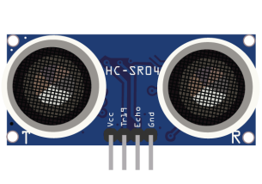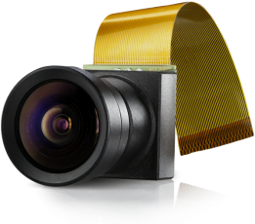

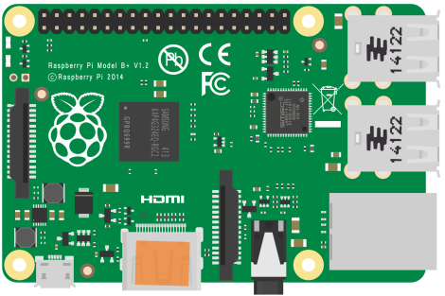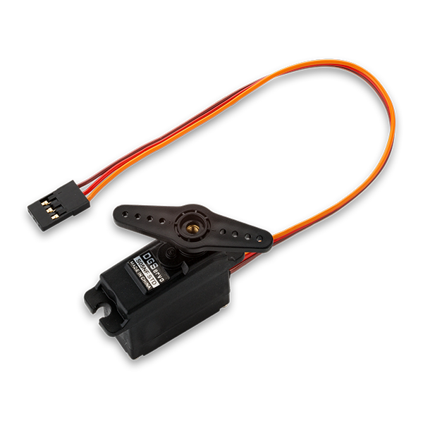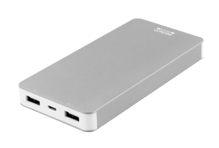

**Servo motor 1:**

For controlling rotating compartment storage

**Servo motor 2:**

For controlling bin closing and object dropping mechanism

**Servo motor 3:**

For controlling coin dispenser for reward-based system

Actuators

**Camera module:**

For capturing and detecting objects

**Ultrasonic sensor:**

For detecting when the bin is full

**Microcontroller**

For controlling all connected components, and responsible for classifying objects

**Power bank:**

Provides power for the entire system

### 9. Research Methodology

#### 9.1. Research Approach

This study employs a **design and implementation-based approach**, integrating both **hardware and software development** to build an AI-driven smart bin for waste sorting. The research follows a **combination of experimental research** (to test the effectiveness of the smart bin) and **descriptive research** (to analyze user interaction and efficiency improvements in waste management).

#### 9.2. System Development Methodology

The **Agile methodology** will be adopted for the development of the smart bin system. Agile is chosen due to its iterative nature, which allows for continuous feedback, testing, and improvements throughout the development cycle. The project will follow these stages:

1. **Requirement Gathering & Analysis** – Identifying the specific needs for waste sorting automation and defining the system functionalities.
2. **Design & Prototyping** – Creating 3D models and electrical circuit schematics to visualize the system.
3. **Development & Implementation** – Iterative coding, AI model training, and hardware integration.
4. **Testing & Evaluation** – Conducting functional and accuracy tests to validate waste classification and user interactions.
5. **Deployment & Feedback** – Deploying a prototype and gathering insights for improvements.

#### 9.3. Materials and Tools

The project will require both **hardware** (for the physical smart bin) and **software** (for AI-based waste classification).

#### **Hardware Components:**

* **Microcontroller/Embedded System:** Raspberry Pi or Arduino for processing inputs.
* **Sensors:** Image sensors or cameras to capture waste images.
* **Actuators:** Servo motors for sorting mechanism.
* **Power Supply:** Rechargeable battery or direct power source.
* **Waste Containers:** Separate compartments for different waste categories.

#### **Software Tools:**

* **AI/ML Development:** TensorFlow/PyTorch for training the waste classification model.
* **Programming Languages:** Python (for AI), C++/MicroPython (for microcontroller programming).
* **Database:** Firebase/MySQL for logging collected data.
* **Simulation & 3D Modeling:** Blender/Fusion 360 for designing the bin prototype.

#### 9.4. System Development Process

The development process includes:

1. **AI Model Training:**
   * Collect and preprocess a dataset of images containing different types of waste (plastic, metal, organic, etc.).
   * Train a deep learning model (CNN-based) to classify waste items.
   * Optimize the model for real-time classification on an embedded system.
2. **Hardware Integration:**
   * Connect sensors and actuators to a microcontroller (e.g., Raspberry Pi).
   * Implement an **object detection algorithm** to trigger waste sorting mechanisms.
   * Develop a mechanism that directs waste to the correct bin.
3. **Software Implementation:**
   * Develop the embedded software that communicates with the AI model.
   * Implement a user interface for monitoring waste classification statistics.
   * Integrate cloud storage for logging waste data.

#### 9.5. Data Collection & Analysis

Data will be collected during system testing, including:

* **Classification Accuracy:** How well the AI model identifies waste types.
* **Sorting Efficiency:** Time taken for the bin to sort an item.
* **User Interaction Feedback:** Ease of use, acceptance, and effectiveness.

Data analysis methods will include:

* **Accuracy Metrics:** Precision, recall, and F1-score for AI classification.
* **Performance Evaluation:** Comparing sorting efficiency before and after system implementation.
* **Usability Testing:** Gathering user feedback to refine the system.

#### 9.6. Validation & Testing

Testing will be conducted in multiple phases:

1. **Unit Testing:** Individual hardware and software components will be tested separately.
2. **System Integration Testing:** Ensuring all components function together seamlessly.
3. **User Acceptance Testing (UAT):** Real-world testing with users to evaluate efficiency and effectiveness.

#### 9.7. Ethical Considerations

* **Data Privacy:** Images used for AI training will be collected responsibly without violating ethical data usage guidelines.
* **Environmental Impact:** The system is designed to **promote sustainability** by improving waste management.
* **User Safety:** Proper safety measures will be implemented in the hardware to prevent mechanical hazards.

#### 9.8. Summary

This methodology outlines the structured approach to designing and developing an AI-driven smart bin that automates waste sorting. The use of Agile methodology ensures continuous improvements, while AI and embedded systems facilitate real-time waste classification and disposal. Data collection and testing will validate the accuracy, performance, and usability of the system.

### 10. Ethical Issues in Computer Science, Computer Engineering, and Information Systems Research

* **Privacy Concerns:** IoT-enabled waste bins may collect user data; **privacy policies must be implemented**.
* **Bias in AI Models:** The classification algorithm must be **trained on diverse waste datasets** to avoid bias.
* **Environmental Responsibility:** The system itself should be **energy-efficient** and use **recyclable components** where possible.
* **Accessibility:** The design should be **user-friendly** for people with disabilities.

### 11. Project Timeline (Gantt Chart)

| ****Task**** | | ****Duration**** | **March** | | April | | May | | June | July | August | |
| --- | --- | --- | --- | --- | --- | --- | --- | --- | --- | --- | --- | --- |
|  | |  | |  | |  |  |  | |
| **1. Project Planning and research** | Finalising project scope | 2 weeks |  |  |  | |  | |  |  |  | |
| Conducting literature review | 6 weeks |  | |  |  |  | |  |  |  | |
| Requirements analysis | 8 weeks |  | |  | |  | |  |  |  | |
| 2. System Design and Modelling | Designing system architecture | 4 weeks |  | |  |  |  | |  |  |  | |
| Creating hardware schematic | 8 weeks |  | |  | |  | |  |  |  | |
| Developing 3D model | 4 weeks |  | |  |  |  | |  |  |  | |
| 3. AI Model Development and Training | Colecting waste image dataset |  |  | |  |  |  | |  |  |  | |
| Training waste classification AI |  |  | |  |  |  |  |  |  |  | |
| Optimising for embedded system |  |  | |  | |  |  |  |  |  | |
| 4. Hardware development and integration | Assembling bin hardware |  |  | |  | |  | |  |  |  | |
| Integrating AI with microcontroller |  |  | |  | |  | |  |  |  | |
| Programming sorting mechanism |  |  | |  | |  | |  |  |  | |
| 5. Testing and optimisation | Testing model accuracy |  |  | |  | |  | |  |  |  | |
| Evaluating hardware efficiency |  |  | |  | |  | |  |  |  | |
| Refining model performance |  |  | |  | |  | |  |  |  |  |
| 6. Documentation and final presentation | Completing project report |  |  | |  | |  | |  |  |  | |
| Preparing final presentation |  |  | |  | |  | |  |  |  | |
| Submission and project defense |  |  | |  | |  | |  |  |  | |

11. Financial Implications (Estimated Budget)

| ****Component**** | ****Estimated Cost (ZMW)**** |
| --- | --- |
| Microcontroller (e.g., Raspberry Pi/ESP32) | K450 |
| Camera Module (for AI vision) | K400 |
| Breadboard | K200 |
| Servo motor x 2 | K500 |
| Power Supply & Battery | K350 |
| Hot glue gun | K130 |
| Glue sticks | K30 |
| Ultrasonic sensor | K500 |
| Miscellaneous (Wiring, PCB, Enclosure) | K350 |
| **Total Estimated Cost** | **K2910** |

### 12. References

*Nkwazi Magazine*. (2019, May 7). Waste management, a challenge for Zambia.

*sopor.nu*. (2023, August 17). Facts about waste management.

Aleena V.J.\*, Kavya Balakrishnan, Rosmi T.B., Swathy Krishna K.J., Sreejith S & T.D.  
Subha. (2017, June 21).

Recycleeye. (2019). AI and Waste Recognition – Why It Works So Well.  
https://recycleye.com/ai-and-waste-recognition-why-it-works-so-well/

## APPENDIX II: HARDWARE SPECIFICATIONS

**Main Controller:**

ESP32-CAM Development Board

**Motors/Actuators:**

2x Servo Motors

Coin Dispenser Servo: Connected to GPIO 13

Sliding Motor Servo: Connected to GPIO 4

Both operate 0-180° range

Speed: ~4 seconds for 90° movement (configurable)

**Sensors:**

Ultrasonic Distance Sensor

Detects when items are dropped into the bin

Triggers the classification process

**Computer Requirements:**

Laptop/PC running Ubuntu Linux

Python 3.8+ with virtual environment

4GB+ RAM for AI model processing

Bluetooth capability for ESP32 communication

## APPENDIX III: SOURCE CODE

The full source code is available on <https://github.com/bulaya-ute/SmartBin.> Code snippets of some of the relevant functional parts are provided below:

### Servo Initialization

|  |
| --- |
| void initServos() {  Serial.println("[Servo] Initializing servo motors...");    yield(); // Prevent watchdog timeout  coinServo.attach(COIN\_DISPENSER\_PIN);  Serial.println("[Servo] Coin dispenser attached to GPIO " + String(COIN\_DISPENSER\_PIN));  delay(10);    yield(); // Prevent watchdog timeout  slidingServo.attach(SLIDING\_MOTOR\_PIN);  Serial.println("[Servo] Sliding motor attached to GPIO " + String(SLIDING\_MOTOR\_PIN));  delay(10);    // Move to home positions  Serial.println("[Servo] Moving to home positions: Coin=" + String(currentCoinPosition) + "°, Sliding=" + String(currentSlidingPosition) + "°");  coinServo.write(currentCoinPosition); // Coin dispenser home: 0°  slidingServo.write(currentSlidingPosition); // Sliding motor home: 90°    delay(500);  Serial.println("[Servo] Initialization complete!"); |

### Binary Classification Processing

|  |
| --- |
| // Map 9-class classification to binary for motors  bool isRecyclable = false;  if (detectedClass == "recyclable" ||  detectedClass == "aluminium" || detectedClass == "carton" ||  detectedClass == "glass" || detectedClass == "paper\_and\_cardboard" ||  detectedClass == "plastic") {  isRecyclable = true;  }  if (isRecyclable) {  // Recyclable: Dispense coin, then route to recyclable bin  logMessage("[Sorting] Recyclable material detected (" + detectedClass + ") - dispensing coin and routing to recyclable bin");    // First: Dispense coin  rotateCoinDispenser(COIN\_DISPENSE); // Move to dispense position (0°)  delay(1000);  rotateCoinDispenser(COIN\_HOME); // Return to home (90°)  delay(500);    // Then: Route to recyclable bin  rotateSlidingMotor(SLIDING\_RECYCLABLE); // Move to recyclable position (30°)  delay(3000); // Hold for 3 seconds to allow waste to fall  rotateSlidingMotor(SLIDING\_HOME); // Return to home position (90°)  }else {  // Non-recyclable: Route to non-recyclable bin (no coin)  logMessage("[Sorting] Non-recyclable material detected (" + detectedClass + ") - routing to non-recyclable bin");  rotateSlidingMotor(SLIDING\_NON\_RECYCLABLE); // Move to non-recyclable position (150°)  delay(3000);  rotateSlidingMotor(SLIDING\_HOME); // Return to home position (90°)  } |

### 

### YOLO Backend Integration

|  |
| --- |
| def \_classify\_with\_yolo\_backend(self, image: Image.Image) -> Dict[str, Any]:  """Classify image using the YOLO backend script"""  try:  import subprocess  import tempfile  import os    # Save image to temporary file  with tempfile.NamedTemporaryFile(suffix='.jpg', delete=False) as tmp\_file:  image.save(tmp\_file.name, 'JPEG')  tmp\_path = tmp\_file.name  try:  # Call the YOLO backend script  venv\_python = ".venv/bin/python"  cmd = [  venv\_python, "yolo\_classification\_backend.py",  "--model", "runs/smartbin\_9class/weights/best.pt",  "--image", tmp\_path,  "--json"  ]  result = subprocess.run(cmd, capture\_output=True, text=True, timeout=30)    if result.returncode == 0:  import json  classification\_data = json.loads(result.stdout)  return classification\_data  else:  return {"success": False, "error": f"Backend script error: {result.stderr}"}    finally:  os.unlink(tmp\_path) # Clean up temp file    except Exception as e:  return {"success": False, "error": f"YOLO backend integration error: {e}"} |

## APPENDIX IV: USER AND ADMIN MANUAL

### User Manual

**Step 1: Approach the SmartBin**  
Look for the green "Ready" indicator (when system is operational)  
Make sure you have your waste item ready  
Stand in front of the bin opening

**Step 2: Insert Your Item**  
Drop your item into the SmartBin opening  
Step back and wait - the system will automatically detect your item  
Be patient - the process takes 10-15 seconds

**Step 3: Watch it work**  
The SmartBin will automatically:  
- take a photo of your item  
- classify what type of waste it is using AI  
- sort your item into the correct bin  
- dispense a coin if your item is recyclable!

**Step 4: Collect Your Reward (If Applicable)**  
Listen for the coin dispensing sound  
Look for the coin in the reward slot  
Collect your coin as a thank you for recycling.

### Admin Manual

#### 🔧 Pre-Operation Setup

1. Hardware Preparation

* Ensure ESP32-CAM is powered and connected
* Verify servo motors are attached and calibrated
* Check coin dispenser is loaded with coins
* Confirm ultrasonic sensor is positioned correctly
* Ensure waste bins are empty and properly positioned

2. Software Environment

* Laptop/PC is charged and ready
* Python virtual environment is activated
* Required Python packages are installed
* YOLO model file exists: runs/smartbin\_9class/weights/best.pt
* Bluetooth is enabled on the laptop

3. Network & Permissions

* Administrator password is available
* Bluetooth permissions are configured
* ESP32 MAC address is known: EC:E3:34:15:F2:62 (default)

#### System Startup

Step 1: Power On ESP32

* Connect power to ESP32-CAM
* Wait for blue LED flash (boot complete)
* ESP32 initializes: Camera, servos, Bluetooth ("SmartBin\_ESP32")

Step 2: Start GUI Application

* source .venv/bin/activate
* python smartbin\_gui.py

Step 3: Connect to System

* Enter administrator password when prompted
* Verify ESP32 MAC: EC:E3:34:15:F2:62 (default)
* Click "connect" button
* Wait for "Connected" status

Step 4: System Check

* Send command: test-servos (motors should move and return)
* Send command: status (check system health)
* Ready. System is operational for users